**Department Library Automation**

**PROJECT REPORT**

***Submitted by***

|  |  |  |
| --- | --- | --- |
| **Roll No** | **Name** | **Role** |
| CB.EN.U4CSE19305 | ASHWANTH K | PROJECT MANAGER |
| CB.EN.U4CSE19317 | D T SUVANESH | TESTER |
| CB.EN.U4CSE19318 | DHARUN NARAYANAN L K | DEVELOPER |
| CB.EN.U4CSE19338 | NITHUNA N | BUSINESS ANALYST |
| CB.EN.U4CSE19354 | SWETHA J | DEVELOPER |

***Course – 19CSE314***

***Software Engineering***



**DEPARTMENT OF COMPUTER SCIENCE AND ENGINEERING**

**AMRITA SCHOOL OF ENGINEERING**

**MAY 2022**

Index/Table of Contents

|  |  |  |
| --- | --- | --- |
| S.No | Content | Page No. |
| 1. | Abstract |  |
| 2. | Preview for the project - Introduction, need and motivation, tools used |  |
| 3. | Product Backlog |  |
| 4. | Use case and DFD diagrams |  |
| 5. | Scrum activities |  |
| 6. | Implementation |  |
| 7. | Sample Code |  |
| 8. | Screen shots of Project |  |

**Abstract:**

Department Library Automation is software designed to manage a library's primary housekeeping functions. Libraries use library management systems to keep track of their asset collections and interactions with their patrons. Department Library Automation assist libraries in keeping track of books and their checkouts, as well as subscriber profiles and subscriptions. It is a user-friendly system created to ensure the proper management of books in a library. Maintaining the database for inputting new books and documenting books that have been borrowed with their due dates is another part of library management systems. Department Library Automation makes issue and returning process easy.

1. **Preview for the project**

The automation of library helps in easy access of library material; one can search the book or journal from home. It makes library more flexible as one can know when to add new books or other items, and an Online Public Access Catalogue, online database of materials kept in the library. It allows the search for an item of our choice in the library.

**Tools used:**

Web app => Vscode, frontend: React js, Bootstrap js, backend: Firebase

Mobile app => Android studio, frontend: Java, backend: Firebase

1. **Product Backlog**

**Product backlog report**

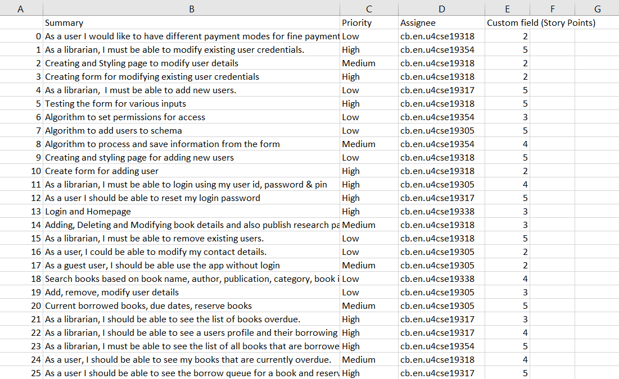

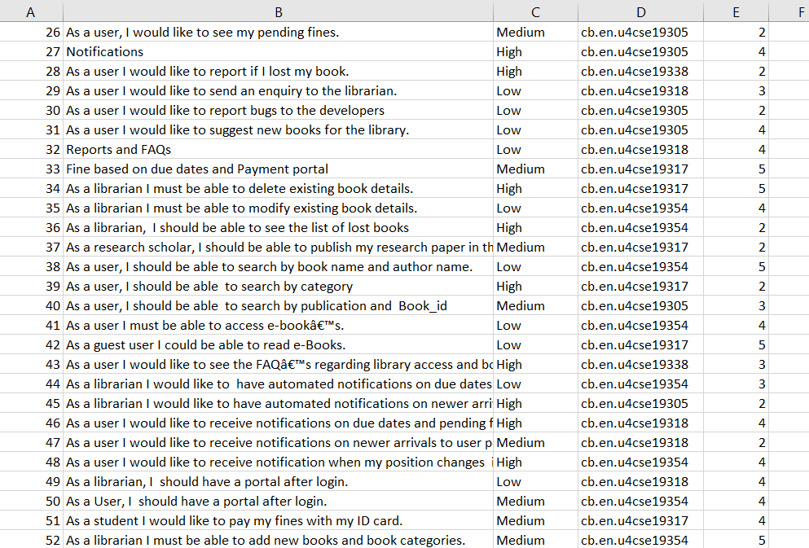

**Epics and User Stories:**

**2.1] Login and Homepage**

**2.1.1] As a librarian, I must be able to login using my user id, password & pin**

**2.1.2]** **As a user I must be able to login using my email id and password.**

**2.1.3]** **As a user I should be able to reset my login password**

**2.1.4]** **As a librarian, I should have a portal after login.**

**2.1.5]** **As a User, I should have a portal after login.**

**2.2] Book Data**

**2.2.1]** **As a librarian I must be able to add new books and book categories.**

**2.2.2]** **As a librarian I must be able to delete existing book details.**

**2.2.3]** **As a librarian I must be able to modify existing book details.**

**2.2.4]** **As a librarian, I should be able to see the list of lost books.**

**2.2.5] As a research scholar I should be able to publish my research paper**

**2.3] Search and OPAC**

**2.3.1]** **As a user, I should be able to search by book name and author name.**

**2.3.2]** **As a user, I should be able to search by category**

**2.3.3]** **As a user, I should be able to search by publication and Book_id**

**2.3.4]** **As a user I must be able to access e-book’s.**

**2.3.5] As a guest user I could be able to read e-Books.**

**2.4] User details**

**2.4.1]** **As a librarian, I must be able to add new users.**

**2.4.2]** **As a librarian, I must be able to remove existing users.**

**2.4.3]** **As a librarian, I must be able to modify existing user credentials.**

**2.4.4]** **As a user, I could be able to modify my contact details.**

**2.4.5] As a guest user, I should be able use the app without login.**

**2.5] Borrow and Due Details**

**2.5.1]** **As a librarian, I must be able to see the list of all books that are borrowed currently and the respective borrowers.**

**2.5.2]** **As a librarian, I should be able to see the list of books overdue.**

**2.5.3]** **As a librarian, I should be able to see a user’s profile and their borrowing history.**

**2.5.4]** **As a user I should be able to see the borrow queue for a book and reserve a book for borrowing.**

**2.5.5] As a user, I should be able to see my books that are currently overdue.**

**2.6] Fine and Payment**

**2.6.1]** **As a librarian, ﻿I would like to see the list of users with pending fines.**

**2.6.2]** **As a user, I would like to see my pending fines.**

**2.6.3]** **As a librarian, ﻿I would like to see the overdue and fine history of every user. 2.6.4] As a student I would like to pay my fines with my ID card.﻿**

**2.6.5] As a user I would like to have different payment modes for fine payment.**

**2.7] Notifications**

**2.7.1]** **As a librarian I would like to have automated notifications on due dates and pending fines sent to user portal.**

**2.7.2]** **As a librarian I would like to have automated notifications on newer arrivals sent to user portal.**

**2.7.3]** **As a user I would like to receive notifications on due dates and pending fines.**

**2.7.4] As a user I would like to receive notifications on newer arrivals to user portal.**

**2.7.5] As a user I would like to receive notification when my position changes in borrow queue**

**2.8] Reports and FAQ**

**2.8.1]** **As a user I would like to report if I lost my book.**

**2.8.2]** **As a user I would like to report bugs to the developers**

**2.8.3]** **As a user I would like to send an enquiry to the librarian.**

**2.8.4] As a user I would like to suggest new books for the library.**

**2.8.5] ﻿As a user I would like to see the FAQ’s regarding library access and borrowing procedures.**

1. **Use case Diagram**

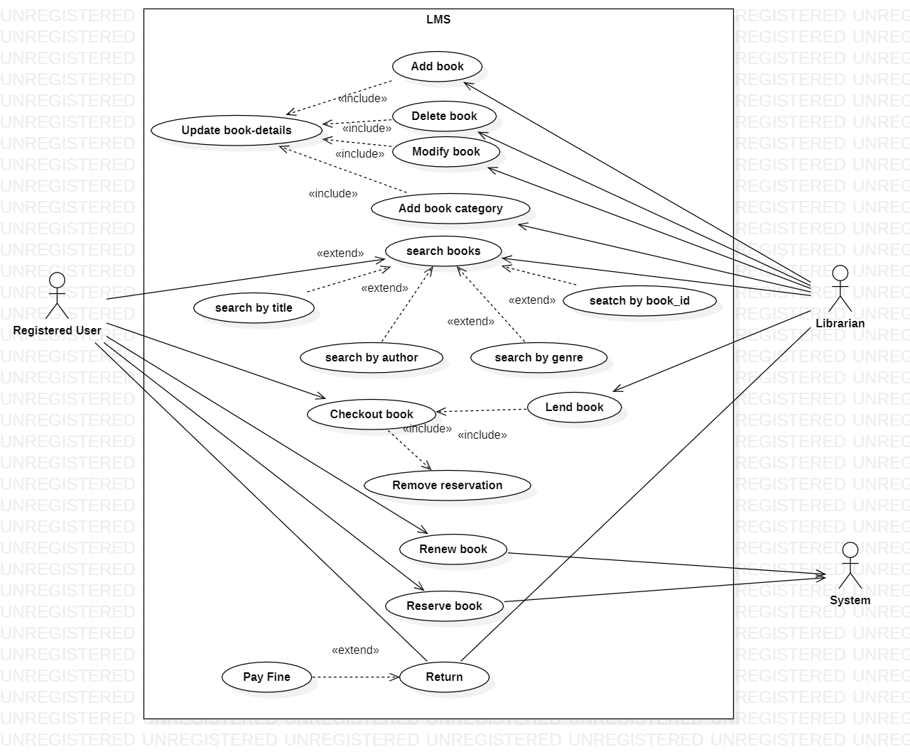

**DFD diagrams:**

**Level 0**

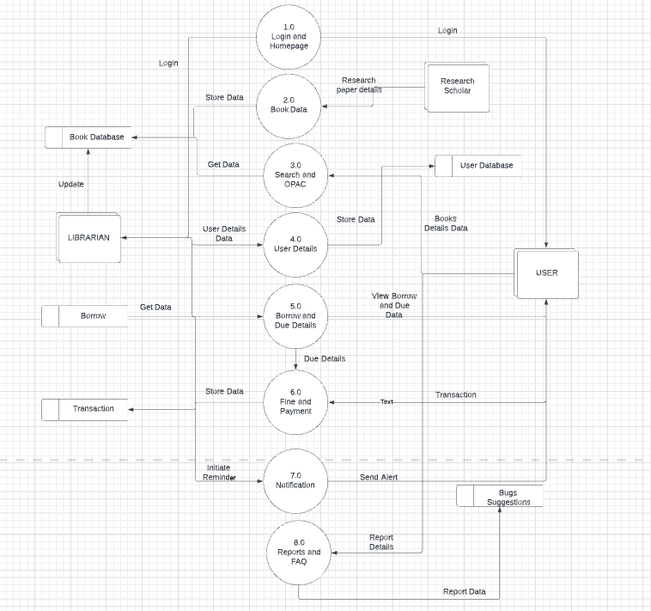

**Level 1**

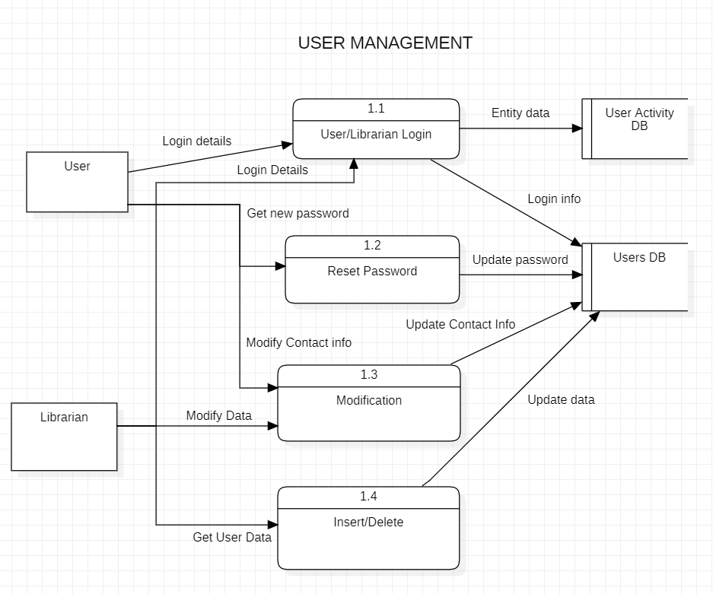

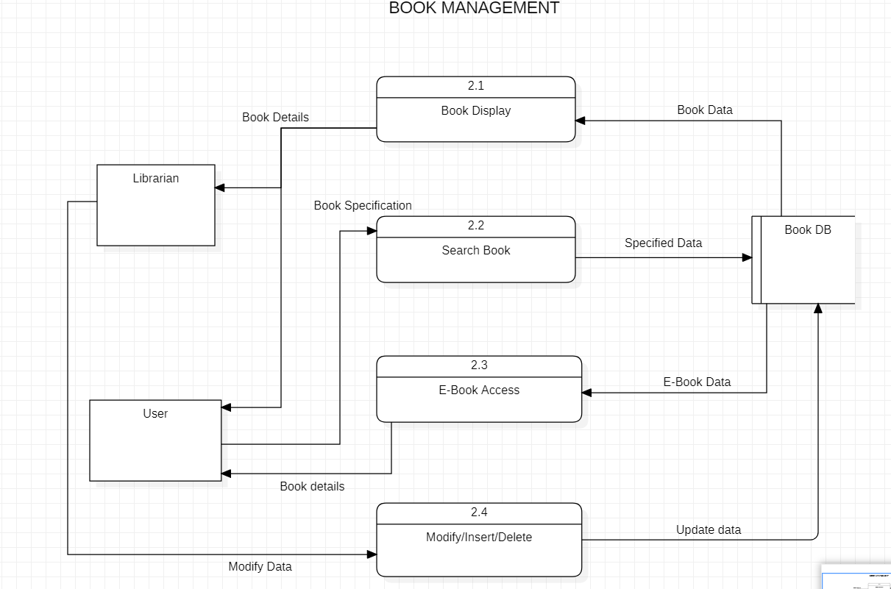

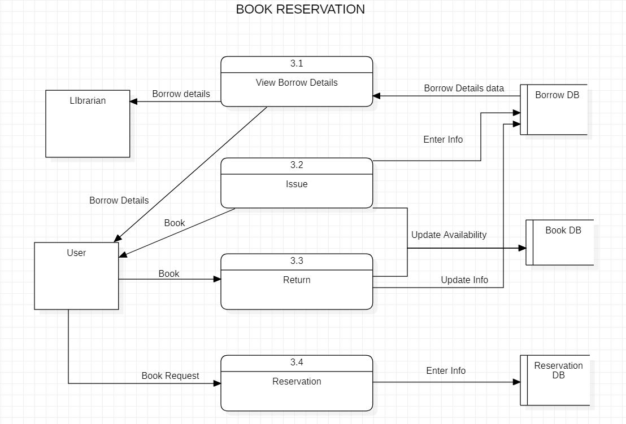

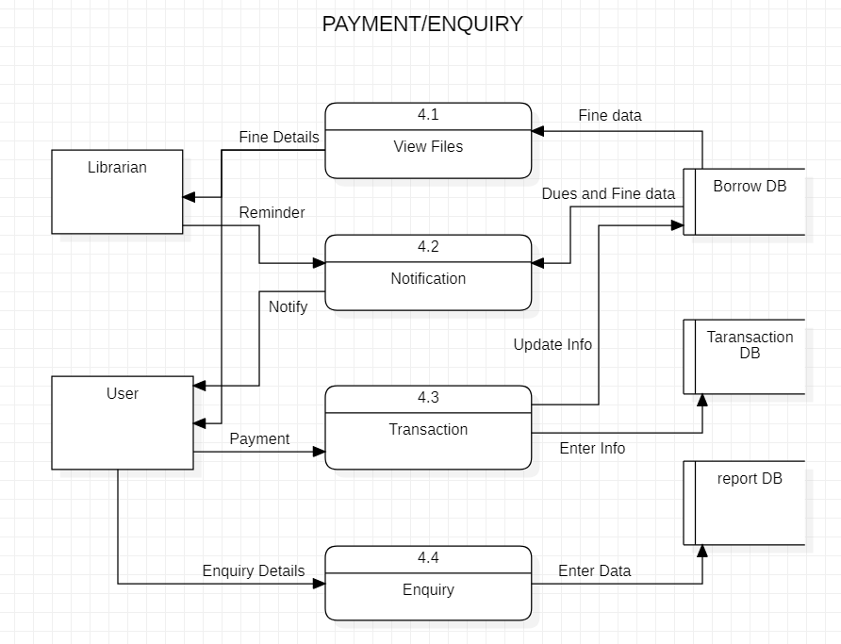

**Level 2:**

**1.1] User Login**

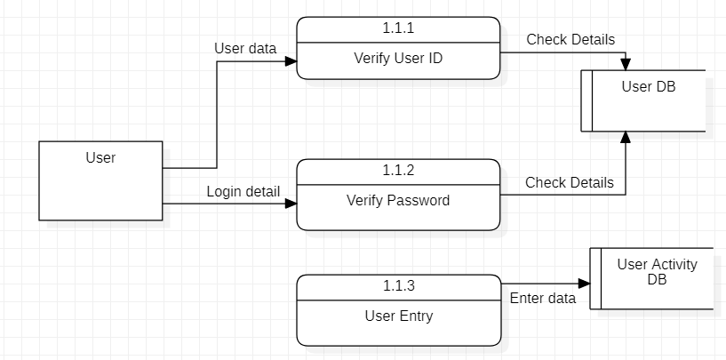

**1.2] Reset Password:**

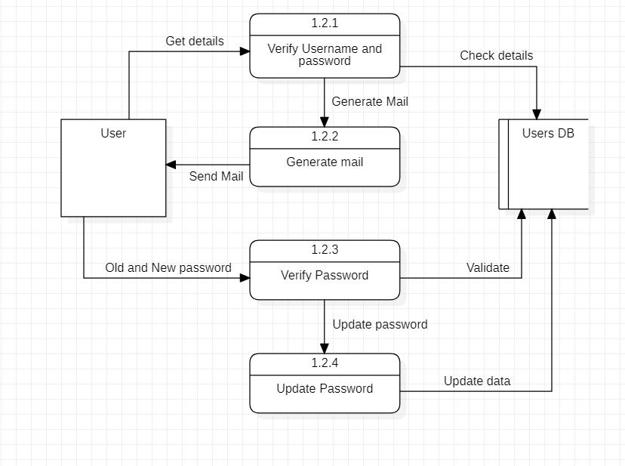

**4. Scrum activities**

**4.1] Sprint 1 standup notes(sample):**

|  |  |  |  |
| --- | --- | --- | --- |
| **Name** | **Question** | **Answer** | **Sign** |
| CB.EN.U4CSE19305 | What did you do yesterday? | Algorithm to authenticate the admin  Adding defaults and requirements for form input. |  |
| What will you do today? | Algorithm to authenticate the user |  |
| Are there any impediments in your way? | no |  |
| CB.EN.U4CSE19317 | What did you do yesterday? | Algorithm to process and validate data from the add user form. |  |
| What will you do today? | Algorithm to process and validate data from the delete user form. |  |
| Are there any impediments in your way? | no |  |
| CB.EN.U4CSE19318 | What did you do yesterday? | Login form creation for librarian for website  Styling, SVG and logo creation for website |  |
| What will you do today? | Login in button for guest user for website  App bar functionalities for website |  |
| Are there any impediments in your way? | Navigation bar must be finished soon |  |
| CB.EN.U4CSE19338 | What did you do yesterday? | Algorithm to authenticate user  Adding on defaults and requirements for form input |  |
| What will you do today? | Algorithm to authenticate the admin |  |
| Are there any impediments in your way? | no |  |
| CB.EN.U4CSE19354 | What did you do yesterday? | Login form creation for librarian for mobile app  Styling, SVG and logo creation for mobile app |  |
| What will you do today? | Login in button for guest user for mobile app  App bar functionalities for mobile app |  |
| Are there any impediments in your way? | App bar must be finished soon |  |

|  |  |  |  |
| --- | --- | --- | --- |
| **Name** | **Question** | **Answer** | **Sign** |
| CB.EN.U4CSE19305 | What did you do yesterday? | Algorithm to authenticate the user  Algorithm to send email prompt for password reset. |  |
| What will you do today? | Algorithm to add books to database. |  |
| Are there any impediments in your way? | Book addition form needs to be completed |  |
| CB.EN.U4CSE19317 | What did you do yesterday? | Algorithm to process and validate data from the delete user form. |  |
| What will you do today? | Algorithm to process and validate data from the modify user form. |  |
| Are there any impediments in your way? | no |  |
| CB.EN.U4CSE19318 | What did you do yesterday? | Login in button for guest user for website  App bar functionalities for website |  |
| What will you do today? | Setting up navigation menu and profile styling |  |
| Are there any impediments in your way? | no |  |
| CB.EN.U4CSE19338 | What did you do yesterday? | Algorithm to authenticate the admin |  |
| What will you do today? | Algorithm to send email prompt for password reset |  |
| Are there any impediments in your way? | Need to finish the password reset form |  |
| CB.EN.U4CSE19354 | What did you do yesterday? | Login in button for guest user for mobile app  App bar functionalities for mobile app |  |
| What will you do today? | Setting up navigation menu and profile styling |  |
| Are there any impediments in your way? | no |  |

|  |  |  |  |
| --- | --- | --- | --- |
| **Name** | **Question** | **Answer** | **Sign** |
| CB.EN.U4CSE19305 | What did you do yesterday? | Algorithm to add books to database. |  |
| What will you do today? | Algorithm to delete books from database |  |
| Are there any impediments in your way? | no |  |
| CB.EN.U4CSE19317 | What did you do yesterday? | Algorithm to process and validate data from the modify user form. |  |
| What will you do today? | Algorithm to process and validate data from the add book form. |  |
| Are there any impediments in your way? | no |  |
| CB.EN.U4CSE19318 | What did you do yesterday? | Setting up navigation menu and profile styling |  |
| What will you do today? | Creating add books form  Profile page form |  |
| Are there any impediments in your way? | no |  |
| CB.EN.U4CSE19338 | What did you do yesterday? | Algorithm to send email prompt for password reset |  |
| What will you do today? | Algorithm to add user to database |  |
| Are there any impediments in your way? | no |  |
| CB.EN.U4CSE19354 | What did you do yesterday? | Setting up navigation menu and profile styling |  |
| What will you do today? | Creating add user form  Profile page form |  |
| Are there any impediments in your way? | Need to finish setting up profile link to database |  |

|  |  |  |  |
| --- | --- | --- | --- |
| **Name** | **Question** | **Answer** | **Sign** |
| CB.EN.U4CSE19305 | What did you do yesterday? | Algorithm to delete books from database |  |
| What will you do today? | Algorithm to modify book details in database. |  |
| Are there any impediments in your way? | no |  |
| CB.EN.U4CSE19317 | What did you do yesterday? | Algorithm to process and validate data from the add book form. |  |
| What will you do today? | Algorithm to process and validate data from the delete book form. |  |
| Are there any impediments in your way? | no |  |
| CB.EN.U4CSE19318 | What did you do yesterday? | Creating add user form  Profile page form |  |
| What will you do today? | Password reset and contact us form |  |
| Are there any impediments in your way? | no |  |
| CB.EN.U4CSE19338 | What did you do yesterday? | Algorithm to add user to database |  |
| What will you do today? | Algorithm to retrieve data for profile details |  |
| Are there any impediments in your way? | no |  |
| CB.EN.U4CSE19354 | What did you do yesterday? | Creating add user form  Profile page form |  |
| What will you do today? | Password reset and contact us form |  |
| Are there any impediments in your way? | no |  |

**4.2] Sprint-1 Retrospective notes:**

|  |  |  |  |
| --- | --- | --- | --- |
| **Sl.no** | **START** | **CONTINUE** | **STOP** |
| 1 | Algorithm to search the books from database | Developing payments application | Stop pushing deadlines |
| 2 | E-book access for both user and guest user on successful authentication | UI complexion | Login and authentication development |
| 3 | Create notification and borrow details to be viewed | Working with the same team spirit | Stop irregular stand ups |
| 4 | Start doing testing for every component | Update research paper publication | User and book details operations |
| 5 | Frequent team meeting | Home page development | Making frequent changes |

**4.3] Sprint 2 backlog:**

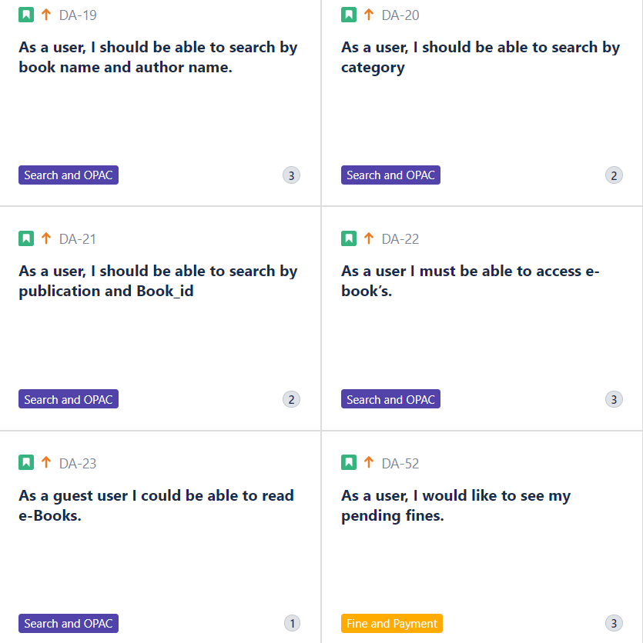

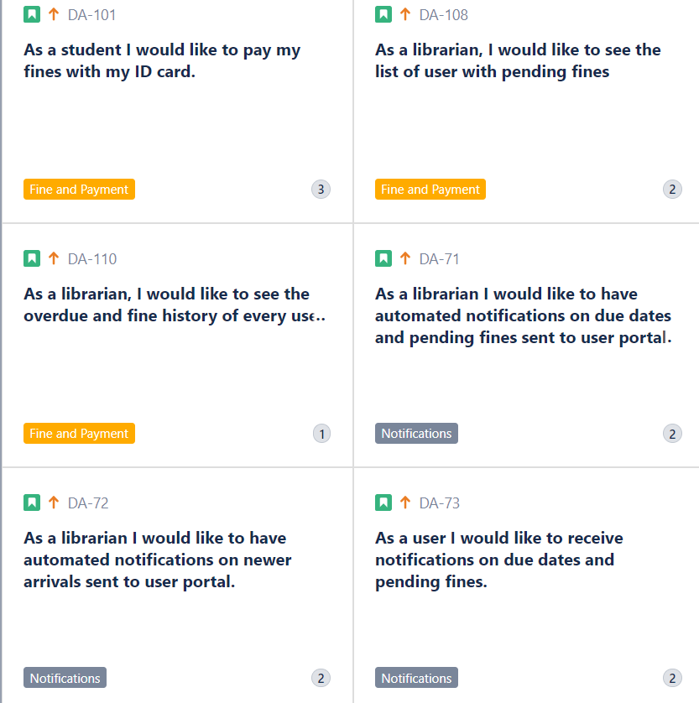

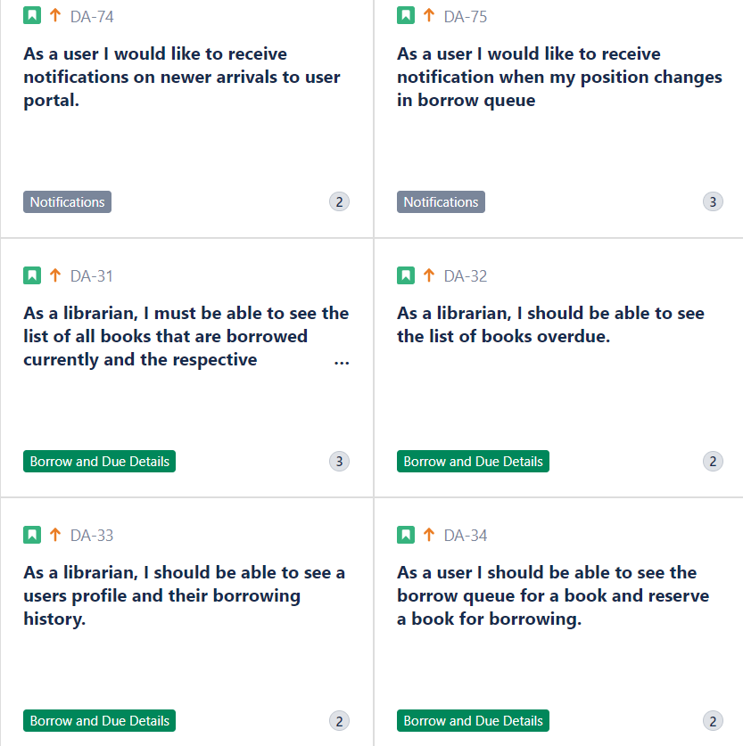

**4.4] Sprint-2 standup notes:**

|  |  |  |  |
| --- | --- | --- | --- |
| **Name** | **Question** | **Answer** | **Sign** |
| CB.EN.U4CSE19305 | What did you do yesterday? | Algorithm to update the user schema. |  |
| What will you do today? | Algorithm to send email prompt for password reset. |  |
| Are there any impediments in your way? | no |  |
| CB.EN.U4CSE19317 | What did you do yesterday? | Algorithm to add email service to contact form |  |
| What will you do today? | Algorithm to push contact info to database |  |
| Are there any impediments in your way? | no |  |
| CB.EN.U4CSE19318 | What did you do yesterday? | Creating delete book form and intending in view  Creating modify book form and indenting in view |  |
| What will you do today? | Creating modify contact form and profile page |  |
| Are there any impediments in your way? | no |  |
| CB.EN.U4CSE19338 | What did you do yesterday? | Algorithm to delete book details from database  Algorithm to modify book details from database |  |
| What will you do today? | Algorithm to retrieve and change user contact info in schema |  |
| Are there any impediments in your way? | no |  |
| CB.EN.U4CSE19354 | What did you do yesterday? | Creating delete book form and intending in view  Creating modify book form and indenting in view |  |
| What will you do today? | Creating modify contact form and profile page |  |
| Are there any impediments in your way? | no |  |
|  |  |  |  |

|  |  |  |  |
| --- | --- | --- | --- |
| **Name** | **Question** | **Answer** | **Sign** |
| CB.EN.U4CSE19305 | What did you do yesterday? | Algorithm to add users to schema. |  |
| What will you do today? | Algorithm to update the user schema. |  |
| Are there any impediments in your way? | no |  |
| CB.EN.U4CSE19317 | What did you do yesterday? | Algorithm to add email service to contact form |  |
| What will you do today? | Algorithm to add email service to contact form |  |
| Are there any impediments in your way? | Api not working |  |
| CB.EN.U4CSE19318 | What did you do yesterday? | Creating delete books form and intending in view  Creating modify book form and indenting in view |  |
| What will you do today? | Creating Add books form and intending in view |  |
| Are there any impediments in your way? | no |  |
| CB.EN.U4CSE19338 | What did you do yesterday? | Algorithm to add books to database |  |
| What will you do today? | Algorithm to delete book details from database  Algorithm to modify book details from database |  |
| Are there any impediments in your way? | no |  |
| CB.EN.U4CSE19354 | What did you do yesterday? | Creating Add books form and intending in view |  |
| What will you do today? | Creating delete books form and intending in view  Creating modify book form and indenting in view |  |
| Are there any impediments in your way? | no |  |

|  |  |  |  |
| --- | --- | --- | --- |
| **Name** | **Question** | **Answer** | **Sign** |
| CB.EN.U4CSE19305 | What did you do yesterday? | Algorithm to modify book details in database. |  |
| What will you do today? | Algorithm to add users to schema. |  |
| Are there any impediments in your way? | User forms need to be completed. |  |
| CB.EN.U4CSE19317 | What did you do yesterday? | Algorithm to process and validate data from the delete book form. |  |
| What will you do today? | Algorithm to process and validate data from the modify book form. |  |
| Are there any impediments in your way? | no |  |
| CB.EN.U4CSE19318 | What did you do yesterday? | Password reset and contact us form |  |
| What will you do today? | Creating delete user form  Creating modify user detail form |  |
| Are there any impediments in your way? | no |  |
| CB.EN.U4CSE19338 | What did you do yesterday? | Algorithm to retrieve data for profile details and view |  |
| What will you do today? | Algorithm to delete users from database  Algorithm to modify user details in schema |  |
| Are there any impediments in your way? | no |  |
| CB.EN.U4CSE19354 | What did you do yesterday? | Password reset and contact us form |  |
| What will you do today? | Creating delete user form  Creating modify user detail form |  |
| Are there any impediments in your way? | no |  |

|  |  |  |  |
| --- | --- | --- | --- |
| **Name** | **Question** | **Answer** | **Sign** |
| CB.EN.U4CSE19305 | What did you do yesterday? | Algorithm to add users to schema. |  |
| What will you do today? | Algorithm to remove users from schema. |  |
| Are there any impediments in your way? | no |  |
| CB.EN.U4CSE19317 | What did you do yesterday? | Algorithm to process and validate data from the modify book form. |  |
| What will you do today? | Algorithm to add email service to contact form |  |
| Are there any impediments in your way? | no |  |
| CB.EN.U4CSE19318 | What did you do yesterday? | Creating delete user form  Creating modify user detail form |  |
| What will you do today? | Creating Add books form and intending in view |  |
| Are there any impediments in your way? | no |  |
| CB.EN.U4CSE19338 | What did you do yesterday? | Algorithm to delete users from schema  Algorithm to modify user details in schema |  |
| What will you do today? | Algorithm to add books to database |  |
| Are there any impediments in your way? | no |  |
| CB.EN.U4CSE19354 | What did you do yesterday? | Creating delete user form  Creating modify user detail form |  |
| What will you do today? | Creating Add books form and intending in view |  |
| Are there any impediments in your way? | no |  |

## **5] Backlog grooming(sample)**

## Epic: Login and Homepage (24 Points)

## **As a librarian, I must be able to login using my user id, password & pin from website** (4 points)

|  |  |  |  |
| --- | --- | --- | --- |
| **Task** | **Member** | **Priority** | **Estimate (Hours)** |
| **Login form creation for librarian** | Dharun | High | 2 |
| **Styling, SVG and logo creation** | Dharun | 1 |
| **Algorithm to process information from the form.** | Ashwanth | 1 |
| **Algorithm to authenticate the user** | Ashwanth | 2 |
| **Adding defaults and requirements for form input.** | Suvanesh | 1 |
| **Testing the form for various inputs.** | Suvanesh | 1 |

## **As a librarian, I must be able to login using my user id, password & pin from mobile-app** (4 points)

|  |  |  |  |
| --- | --- | --- | --- |
| **Task** | **Member** | **Priority** | **Estimate (Hours)** |
| **Login form creation for librarian** | Swetha | High | 2 |
| **Styling, SVG and logo creation** | Swetha | 1 |
| **Algorithm to process information from the form.** | Nithuna | 1 |
| **Algorithm to authenticate the user** | Nithuna | 2 |
| **Adding defaults and requirements for form input.** | Suvanesh | 1 |
| **Testing the form for various inputs.** | Suvanesh | 1 |

## **As a user I must be able to login using my email id and password from website** (3 points)

|  |  |  |  |
| --- | --- | --- | --- |
| **Task** | **Member** | **Priority** | **Estimate (Hours)** |
| **Login form creation for user** | Dharun | High | 1 |
| **Styling, SVG and logo creation** | Dharun | 1 |
| **Algorithm to process information from the form.** | Ashwanth | 1 |
| **Algorithm to authenticate the user** | Ashwanth | 1 |
| **Adding defaults and requirements for form input.** | Suvanesh | 1 |
| **Testing the form for various inputs.** | Suvanesh | 1 |

## **As a User, I must be able to login using my user id & password from mobile-app** (3 points)

|  |  |  |  |
| --- | --- | --- | --- |
| **Task** | **Member** | **Priority** | **Estimate (Hours)** |
| **Login form creation for librarian** | Swetha | High | 1 |
| **Styling, SVG and logo creation** | Swetha | 1 |
| **Algorithm to process information from the form.** | Nithuna | 1 |
| **Algorithm to authenticate the user** | Nithuna | 1 |
| **Adding defaults and requirements for form input.** | Suvanesh | 1 |
| **Testing the form for various inputs.** | Suvanesh | 1 |

## **As a user I should be able to reset my login password from webapp** (5 points)

|  |  |  |  |
| --- | --- | --- | --- |
| **Task** | **Member** | **Priority** | **Estimate (Hours)** |
| **Creating Security question form.** | Dharun | Medium | 2 |
| **Algorithm to validate the security answer.** | Suvanesh | 1 |
| **Algorithm to send email prompt for password reset.** | Ashwanth | 2 |
| **Password reset form design and styling** | Dharun | 1 |
| **Algorithm to update password in database** | Ashwanth | 2 |
| **Testing the working of password reset mechanism.** | Suvanesh | 1 |

## **As a user I should be able to reset my login password from mobile-app** (5 points)

|  |  |  |  |
| --- | --- | --- | --- |
| **Task** | **Member** | **Priority** | **Estimate (Hours)** |
| **Creating Security question form.** | Swetha | Medium | 2 |
| **Algorithm to validate the security answer.** | Nithuna | 1 |
| **Algorithm to send email prompt for password reset.** | Nithuna | 2 |
| **Password reset form design and styling** | Swetha | 1 |
| **Algorithm to update password in database** | Suvanesh | 2 |
| **Testing the working of password reset mechanism.** | Suvanesh | 1 |

**6] Implementation code(sample)**

**Web app:**

import React, { Component } from 'react';

import { BrowserRouter as Router, Switch, Route } from "react-router-dom";

import Home from './components/home'

import Blog from './components/blog'

import Support from './components/support';

import Faq from './components/faq';

import Contact from './components/contact';

import Login from './components/login';

import ALogin from './components/alogin';

import Homepage from './components/homepage';

import RHomepage from './components/rhomepage';

import PublishPaper from './components/publishpaper';

import AHomepage from './components/ahomepage';

import GHomepage from './components/ghomepage';

import Book from './components/book';

import BookModify from './components/book_modify';

import BookDelete from './components/book_delete';

import Opac from './components/opac';

import BookDetail from './components/BookDetail';

import User from './components/user';

import UserModify from './components/user_modify';

import UserDelete from './components/user_delete';

import Profilepage from './components/profilepage';

import RProfilepage from './components/rprofilepage';

class App extends Component {

  render() {

    return (

      <Router>

         <Switch>

          <Route exact path = "/" component = {Home} />

          <Route exact path = "/blog" component = {Blog} />

          <Route exact path='/support' component={Support}/>

          <Route exact path='/faq' component={Faq}/>

          <Route exact path='/contact' component={Contact}/>

          <Route exact path='/login' component={Login}/>

          <Route exact path='/alogin' component={ALogin}/>

          <Route exact path='/homepage/:id' component={Homepage}/>

          <Route exact path='/rhomepage/:id' component={RHomepage}/>

          <Route exact path='/publishpaper' component={PublishPaper}/>

          <Route exact path='/ghomepage' component={GHomepage}/>

          <Route exact path='/ahomepage/:id' component={AHomepage}/>

          <Route exact path='/book' component={Book}/>

          <Route path='/bookdetails/:book'

            render={(routerProps) => {

              return <BookDetail match={routerProps.match} />;

            }}

          />

          <Route exact path='/opac' component={Opac}/>

          <Route exact path='/book_modify' component={BookModify}/>

          <Route exact path='/book_delete' component={BookDelete}/>

          <Route exact path='/user' component={User}/>

          <Route exact path='/user_modify' component={UserModify}/>

          <Route exact path='/user_delete' component={UserDelete}/>

          <Route exact path='/profilepage' component={Profilepage}/>

          <Route exact path='/rprofilepage' component={RProfilepage}/>

        </Switch>

      </Router>

    );

  }

}

export default App;

**Mobile app:**

package com.example.library_automation;  
  
import static android.content.ContentValues.*TAG*;  
  
import android.os.Bundle;  
import android.util.Log;  
import android.view.Menu;  
import android.view.MenuItem;  
import android.widget.Toast;  
  
import androidx.annotation.NonNull;  
import androidx.appcompat.app.ActionBar;  
import androidx.appcompat.app.AppCompatActivity;  
  
import com.example.library_automation.databinding.ActivityAdduserBinding;  
import com.google.android.gms.tasks.OnCompleteListener;  
import com.google.android.gms.tasks.Task;  
import com.google.firebase.auth.AuthResult;  
import com.google.firebase.auth.FirebaseAuth;  
import com.google.firebase.database.DatabaseReference;  
import com.google.firebase.database.FirebaseDatabase;  
  
import java.util.HashMap;  
  
public class Adduser extends AppCompatActivity {  
 ActivityAdduserBinding binding;  
 FirebaseDatabase db;  
 DatabaseReference reference;  
 @Override  
 protected void onCreate(Bundle savedInstanceState) {  
 super.onCreate(savedInstanceState);  
 binding = ActivityAdduserBinding.*inflate*(getLayoutInflater());  
 setContentView(binding.getRoot());  
 ActionBar actionBar = getSupportActionBar();  
 if (actionBar != null) {  
 actionBar.setDisplayHomeAsUpEnabled(true);  
 }  
 binding.adduser.setOnClickListener(view -> {  
 String rollno = binding.rno1.getText().toString();  
 String fname = binding.name1.getText().toString();  
 String lname = binding.lname1.getText().toString();  
 String emailid = binding.email1.getText().toString();  
 String password=binding.pass1.getText().toString();  
 // String course = binding.Course1.getText().toString();  
 String dept = binding.dept1.getText().toString();  
 String year1 = binding.year1.getText().toString();  
 int year = Integer.*parseInt*(year1);  
 String contact = binding.Contact1.getText().toString();  
  
 addUser(rollno,fname,lname,emailid,password,dept,year,contact);  
 });  
 }  
 private void addUser(String rollno,String fname,String lname,String emailid,String password,String dept,int year,String contact) {  
 FirebaseAuth.*getInstance*().createUserWithEmailAndPassword(emailid, password)  
 .addOnCompleteListener(this, new OnCompleteListener<AuthResult>() {  
 @Override  
 public void onComplete(@NonNull Task<AuthResult> task) {  
 if (task.isSuccessful()) {  
 HashMap<String, Object> User = new HashMap<>();  
 User.put("rollNum",rollno);  
 User.put("firstName",fname);  
 User.put("lastName",lname);  
 User.put("email",emailid);  
 User.put("password",password);  
 // User.put("Course",course);  
 User.put("department",dept);  
 User.put("year",year);  
 User.put("contactNum",contact);  
  
 User user = new User(rollno,fname,lname,emailid,password,dept,year,contact);  
 db = FirebaseDatabase.*getInstance*();  
 reference = db.getReference("Users");  
 reference.child(binding.rno1.getText().toString()).updateChildren(User).addOnCompleteListener(taskAdd -> {  
 if (taskAdd.isSuccessful()){  
 binding.rno1.setText("");  
 binding.name1.setText("");  
 binding.lname1.setText("");  
 binding.email1.setText("");  
 binding.pass1.setText("");  
 //binding.Course1.setText("");  
 binding.dept1.setText("");  
 binding.year1.setText("");  
 binding.Contact1.setText("");  
 Toast.*makeText*(Adduser.this,"Successfuly Updated",Toast.*LENGTH_SHORT*).show();  
  
 }else {  
  
 Toast.*makeText*(Adduser.this,"Failed to Update",Toast.*LENGTH_SHORT*).show();  
  
 }  
  
 });  
   
 Log.*d*(*TAG*, "createUserWithEmail:success");  
  
 } else {  
 // If sign in fails, display a message to the user.  
 Log.*w*(*TAG*, "createUserWithEmail:failure", task.getException());  
 Toast.*makeText*(Adduser.this, "Authentication failed.",  
 Toast.*LENGTH_SHORT*).show();  
 }  
 }  
 });  
 }  
 public boolean onOptionsItemSelected(MenuItem item){  
 switch (item.getItemId()) {  
 case android.R.id.*home*:  
 finish();  
 return true;  
 }  
 return super.onOptionsItemSelected(item);  
 }  
  
 public boolean onCreateOptionsMenu(Menu menu) {  
 return true;  
 }  
  
}

**7]** **Software Engineering tools used**

**7.1] Static code analysis**

Tool used: SonarQube

**7.1.1]** **Screenshots of scanning:**

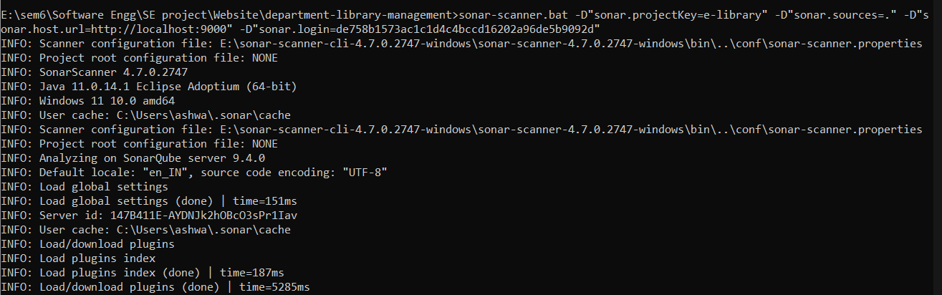

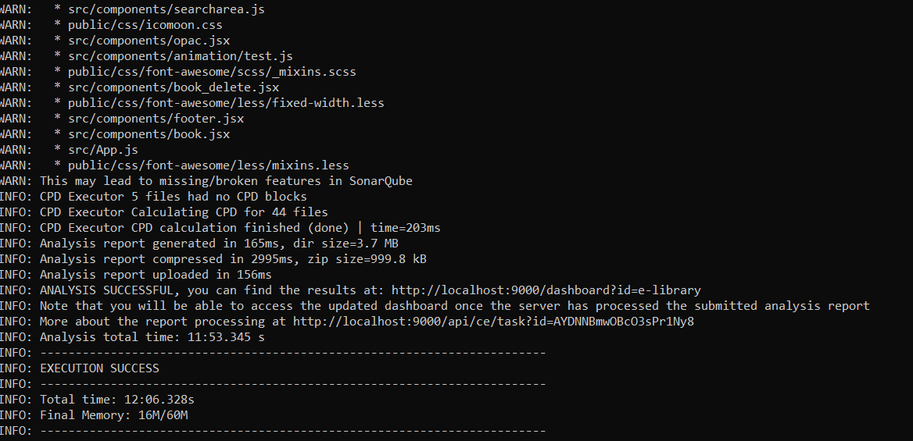

**7.1.2] Reports:**

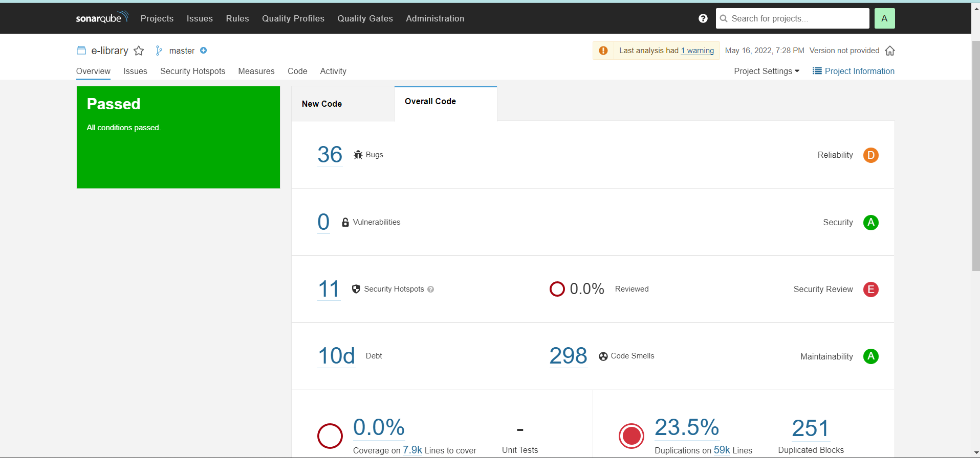

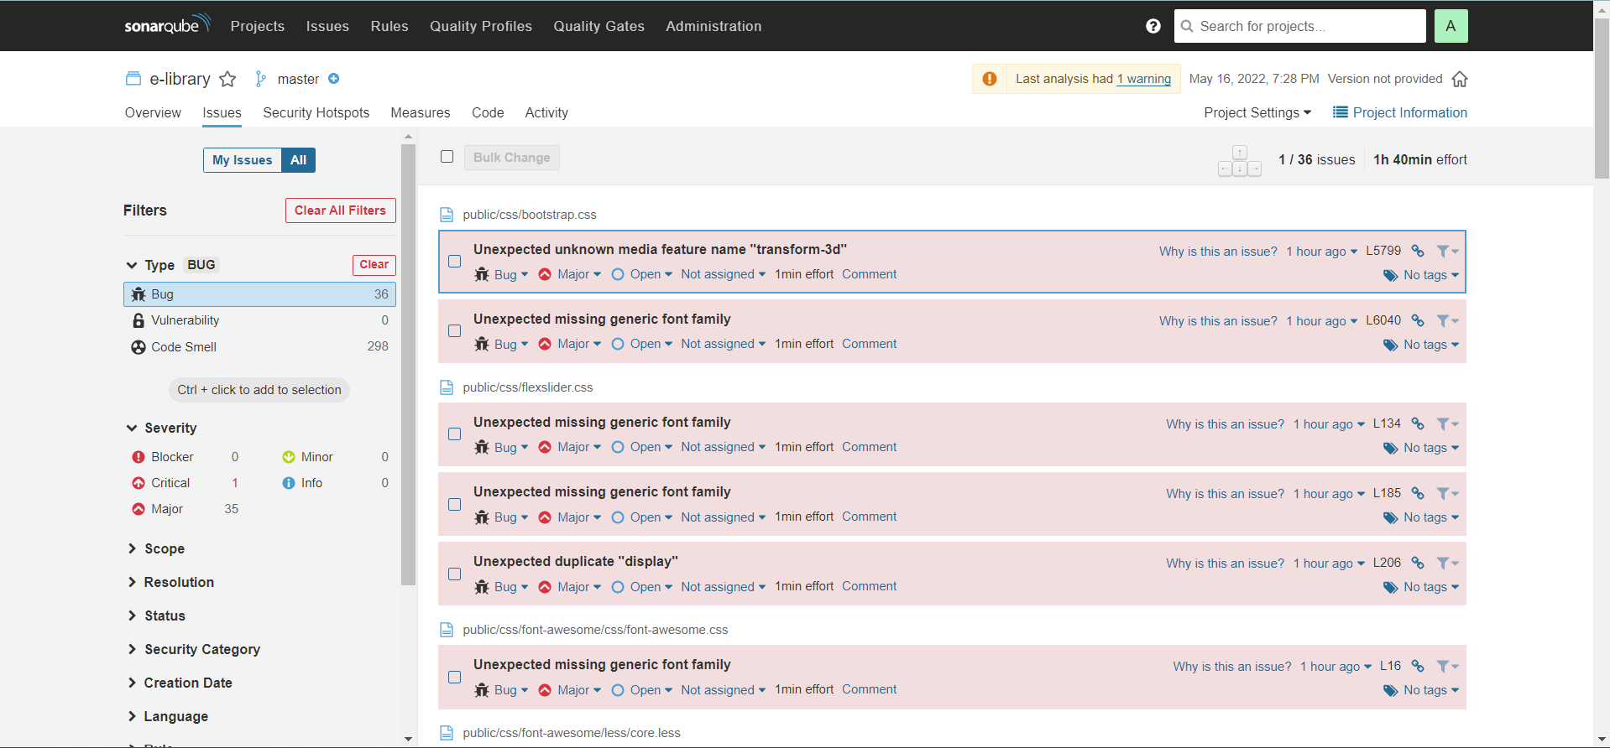

**7.2 Unit Testing**

**Mobile App**

Unit Testing for mobile Application done using Junit5.

**1.**UserValidation Test

CODE:

package com.example.library_automation;  
  
import static org.junit.jupiter.api.Assertions.*;  
  
import org.junit.jupiter.api.Test;  
  
class uservalidationTest {  
  
 @Test  
 public void uservalidation_CorrectEmailSimple_ReturnsTrue() {  
 *assertTrue*(uservalidation.*isValidEmail*("cb.en.u4cse19354@cb.students.amrita.edu"));  
 }  
 @Test  
 public void emailValidator_CorrectEmailSubDomain_ReturnsTrue() {  
 *assertTrue*(uservalidation.*isValidEmail*("cb.en.u4cse19338@aa.bb.amrita.edu"));  
 }  
 @Test  
 public void emailValidator_InvalidEmailusername_ReturnsFalse() {  
 *assertFalse*(uservalidation.*isValidEmail*("cb.en.19354@cb.students.amrita.edu"));  
 }  
 @Test  
 public void emailValidator_InvalidEmailusername1_ReturnsFalse() {  
 *assertFalse*(uservalidation.*isValidEmail*("cb.en.u4cse193ab@cb.students.amrita.edu"));  
 }  
 @Test  
 public void emailValidator_InvalidEmailNoTld_ReturnsFalse() {  
 *assertFalse*(uservalidation.*isValidEmail*("cb.en.u4cse19338@cb.students.amrita"));  
 }  
 @Test  
 public void emailValidator_InvalidEmailDoubleDot_ReturnsFalse() {  
 *assertFalse*(uservalidation.*isValidEmail*("cb.en.u4cse19338@amrita..edu"));  
 }  
 @Test  
 public void emailValidator_InvalidEmailNoUsername_ReturnsFalse() {  
 *assertFalse*(uservalidation.*isValidEmail*("@amrita.edu"));  
 }  
 @Test  
 public void emailValidator_EmptyString_ReturnsFalse() {  
 *assertFalse*(uservalidation.*isValidEmail*(""));  
 }  
 @Test  
 public void emailValidator_NullEmail_ReturnsFalse() {  
 *assertFalse*(uservalidation.*isValidEmail*(null));  
 }  
}

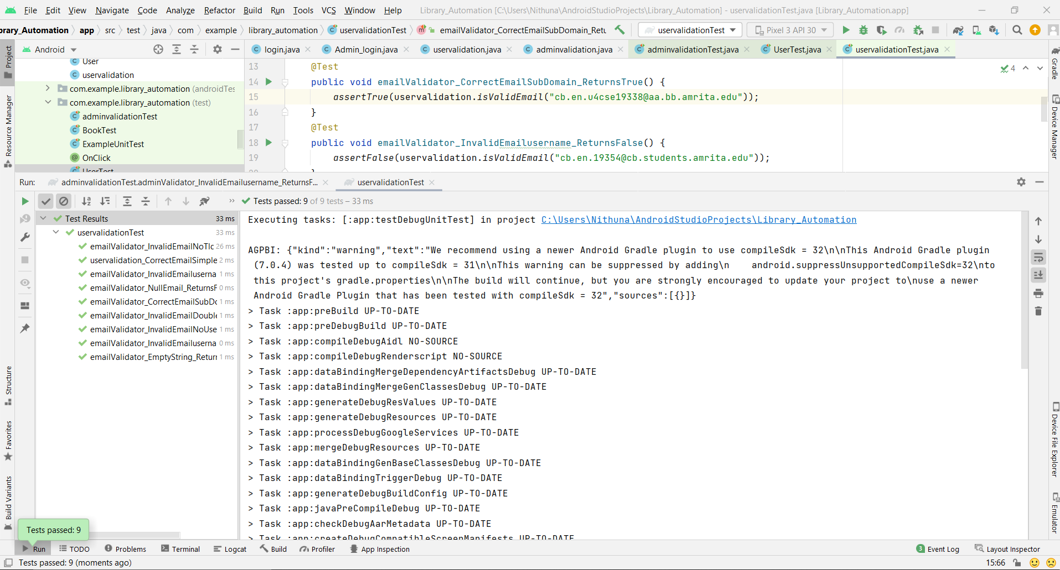

**2.**Book Test

CODE:

package com.example.library_automation;  
  
import static org.junit.jupiter.api.Assertions.*;  
  
import org.junit.jupiter.api.Test;  
  
class BookTest {  
  
 @Test  
 void getBid() {  
 Book b = new Book("123","Java","Elliot .R","785","5");  
 *assertEquals*("123", b.getBid());  
 }  
  
 @Test  
 void getBname() {  
 Book b = new Book("123","Java","Elliot .R","785","5");  
 *assertEquals*("Java", b.getBname());  
 }  
  
 @Test  
 void getAuthor() {  
 Book b = new Book("123","Java","Elliot .R","785","5");  
 *assertEquals*("Elloit .R", b.getAuthor());  
 }  
  
 @Test  
 void getNumcopy() {  
 Book b = new Book("123","Java","Elliot .R","785","5");  
 *assertEquals*("5", b.getNumcopy());  
 }  
}

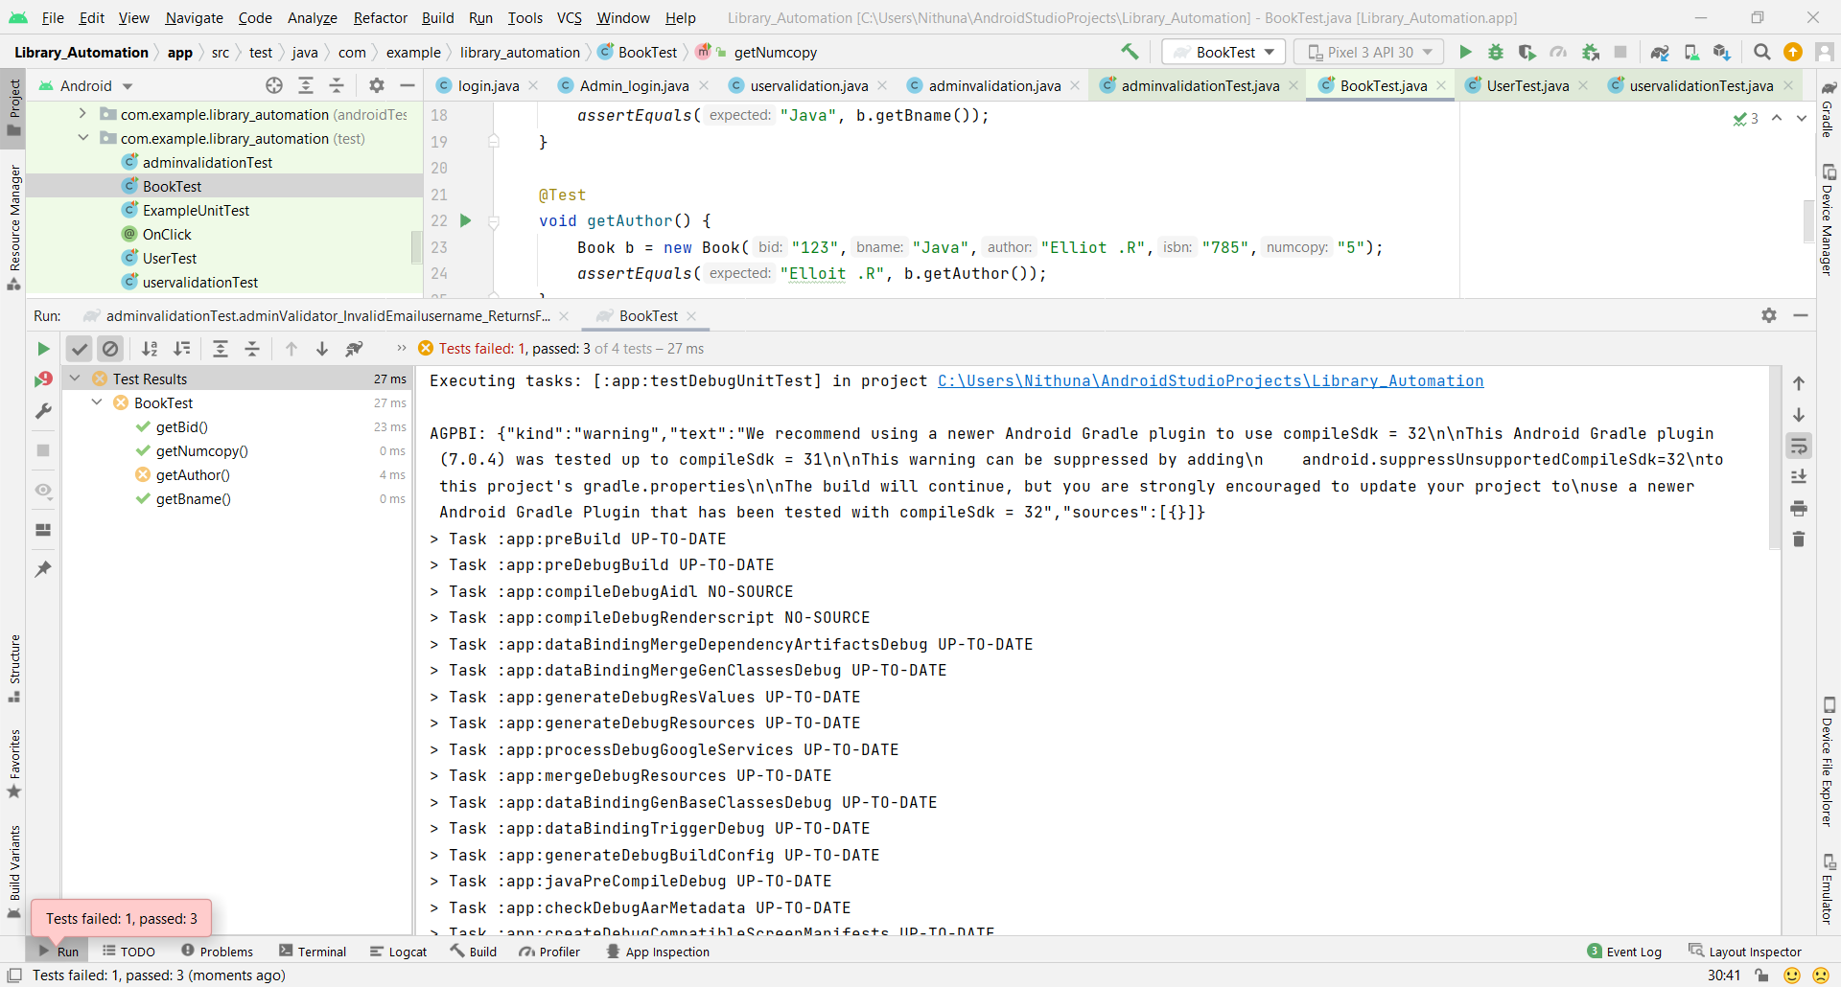

**3.**AdminValidation Test

CODE:

package com.example.library_automation;  
  
import static org.junit.jupiter.api.Assertions.*;  
  
import org.junit.jupiter.api.Test;  
  
class adminvalidationTest {  
  
 @Test  
 public void adminvalidation_CorrectEmailSimple_ReturnsTrue() {  
 *assertTrue*(adminvalidation.*isValidEmail*("cb.admin01@cb.admin.amrita.edu"));  
 }  
 @Test  
 public void adminValidator_CorrectEmailSubDomain_ReturnsTrue() {  
 *assertTrue*(adminvalidation.*isValidEmail*("cb.admin00@aa.bb.amrita.edu"));  
 }  
 @Test  
 public void adminValidator_InvalidEmailusername_ReturnsFalse() {  
 *assertFalse*(adminvalidation.*isValidEmail*("cb.admin@cb.admin.amrita.edu"));  
 }  
 @Test  
 public void adminValidator_InvalidEmailusername1_ReturnsFalse() {  
 *assertFalse*(adminvalidation.*isValidEmail*("cb.01admin@cb.admin.amrita.edu"));  
 }  
 @Test  
 public void adminValidator_InvalidEmailNoTld_ReturnsFalse() {  
 *assertFalse*(adminvalidation.*isValidEmail*("cb.admin02@cb.admin.amrita"));  
 }  
 @Test  
 public void adminValidator_InvalidEmailDoubleDot_ReturnsFalse() {  
 *assertFalse*(adminvalidation.*isValidEmail*("cb.admin00@amrita..edu"));  
 }  
 @Test  
 public void adminValidator_InvalidEmailNoUsername_ReturnsFalse() {  
 *assertFalse*(adminvalidation.*isValidEmail*("@amrita.edu"));  
 }  
 @Test  
 public void adminValidator_EmptyString_ReturnsFalse() {  
 *assertFalse*(adminvalidation.*isValidEmail*(""));  
 }  
 @Test  
 public void adminValidator_NullEmail_ReturnsFalse() {  
 *assertFalse*(adminvalidation.*isValidEmail*(null));  
 }  
}

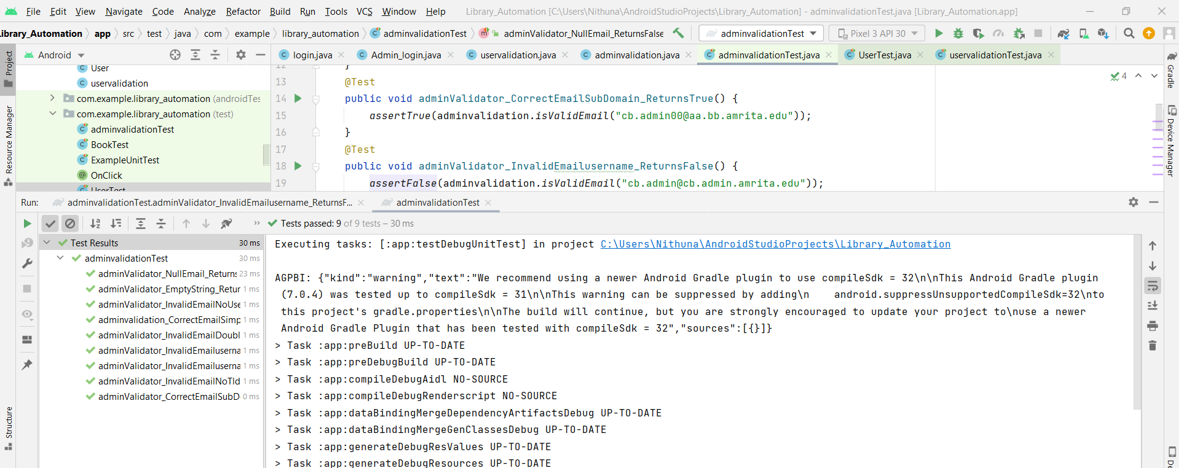

**4.**User Test

CODE:

package com.example.library_automation;  
  
import static org.junit.jupiter.api.Assertions.*;  
  
import org.junit.jupiter.api.Test;  
  
class UserTest {  
  
 @Test  
 void getFname() {  
 User u = new User("Nithuna","n","cb.en.u4cse19338@cb.students.amrita.edu","12345");  
 *assertEquals*("Nithuna", u.getFname());  
 }  
  
 @Test  
 void getLname() {  
 User u = new User("nithuna","n","cb.en.u4cse19338@cb.students.amrita.edu","12345");  
 *assertEquals*("n", u.getLname());  
 }  
  
 @Test  
 void getRollno() {  
 User u = new User("cbenu4cse19338","Nithuna","n","cb.en.u4cse19338@cb.students.amrita.edu","12345","","",5,"");  
 *assertEquals*("cse19338", u.getRollno());  
 }  
  
 @Test  
 void getEmail() {  
 User u = new User("nithuna","n","cb.en.u4cse19338@cb.students.amrita.edu","12345");  
 *assertEquals*("cb.en.u4cse19338@cb.students.amrita.edu", u.getEmail());  
 }  
  
 @Test  
 void getPassword() {  
 User u = new User("nithuna","n","cb.en.u4cse19338@cb.students.amrita.edu","12345");  
 *assertEquals*("pass123", u.getPassword());  
 }  
  
 @Test  
 void getCourse() {  
 User u = new User("cbenu4cse19338","Nithuna","n","cb.en.u4cse19338@cb.students.amrita.edu","12345","b.tech","cse",3,"1234567890");  
 *assertEquals*("b.tech", u.getCourse());  
 }  
  
 @Test  
 void getDept() {  
 User u = new User("cbenu4cse19338","Nithuna","n","cb.en.u4cse19338@cb.students.amrita.edu","12345","b.tech","cse",3,"1234567890");  
 *assertEquals*("cse", u.getDept());  
 }  
  
 @Test  
 void getYear() {  
 User u = new User("cbenu4cse19338","Nithuna","n","cb.en.u4cse19338@cb.students.amrita.edu","12345","b.tech","cse",3,"1234567890");  
 *assertEquals*("4", u.getYear());  
 }  
  
 @Test  
 void getContact() {  
 User u = new User("cbenu4cse19338","Nithuna","n","cb.en.u4cse19338@cb.students.amrita.edu","12345","b.tech","cse",3,"1234567890");  
 *assertEquals*("1234567890", u.getContact());  
 }  
 @Test  
 void setFname() {  
 *fail*("nithy");  
 }  
}

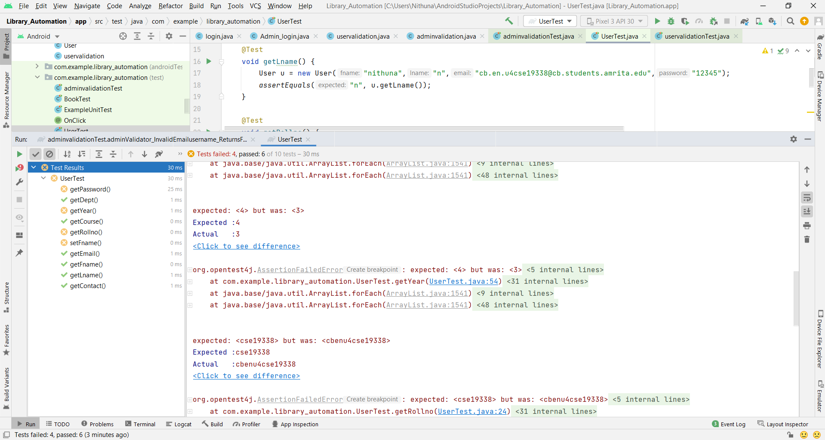

**Web App:**

import { render ,screen , cleanup } from '@testing-library/react';

import ahomepage from './AHomepage';

it('renders without crashing', () => {

    render(<ahomepage />);

    cleanup();

});

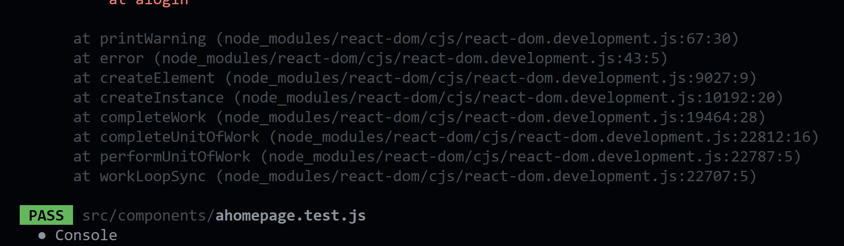

import { render ,screen , cleanup } from '@testing-library/react';

import alogin from './ALogin';

it('renders without crashing', () => {

    render(<alogin />);

    cleanup();

});

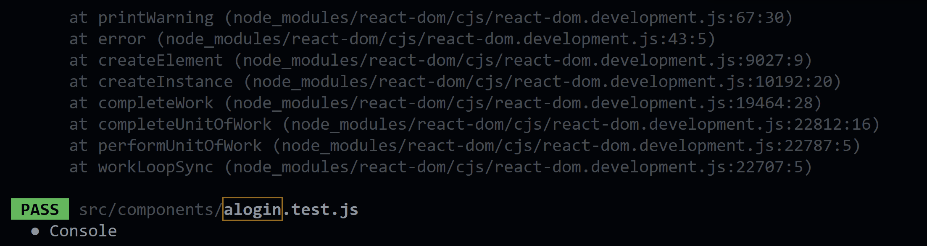

import React from "react";

import ReactDOM from "react-dom";

import scrollToTop from './blog';

import blog from './Blog';

it("renders without crashing", () => {

    const div = document.createElement("div");

    ReactDOM.render(<scorllTOTop />, div);

});

it("renders without crashing", () => {

    const div = document.createElement("div");

    ReactDOM.render(<blog />, div);

});

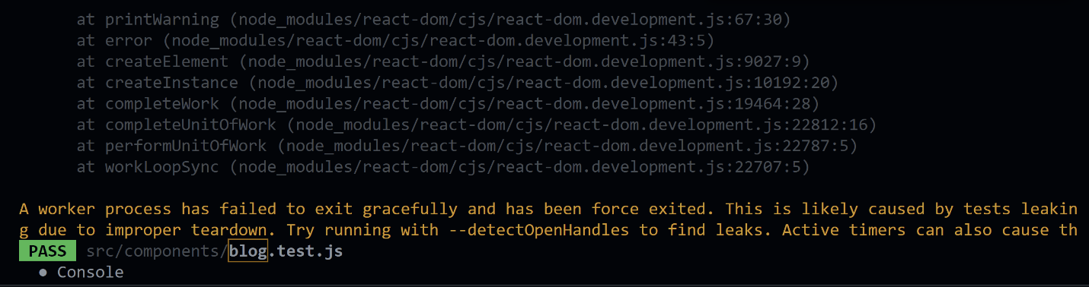

import React from "react";

import ReactDOM from "react-dom";

import scrollToTop from './book_delete';

import book_delete from './book_delete';

it("renders without crashing", () => {

    const div = document.createElement("div");

    ReactDOM.render(<scorllTOTop />, div);

});

it("renders without crashing", () => {

    const div = document.createElement("div");

    ReactDOM.render(<book_delete />, div);

});

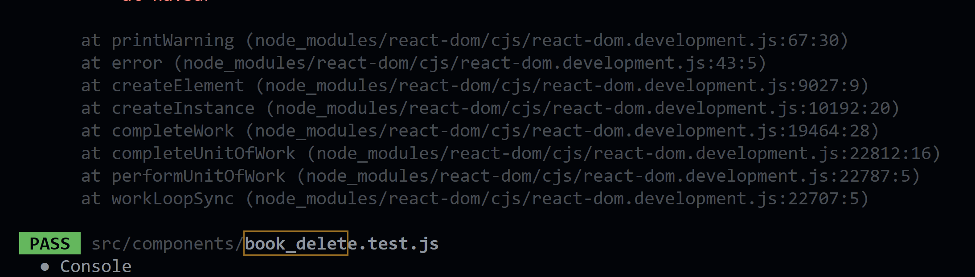

import React from "react";

import ReactDOM from "react-dom";

import scrollToTop from './book_modify';

import book_modify from './book_modify';

it("renders without crashing", () => {

    const div = document.createElement("div");

    ReactDOM.render(<scorllTOTop />, div);

});

it("renders without crashing", () => {

    const div = document.createElement("div");

    ReactDOM.render(<book_modify />, div);

});

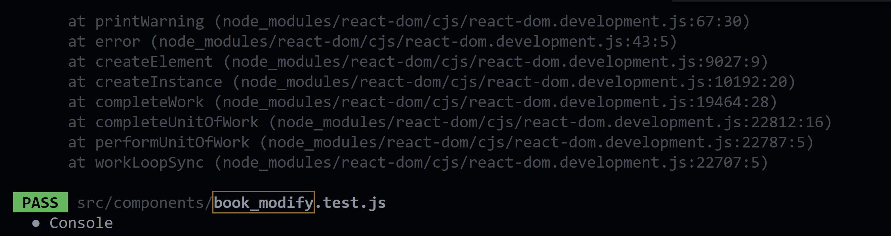

import React from "react";

import ReactDOM from "react-dom";

import scrollToTop from './book';

import book from './book';

import addBook from './book';

it("renders without crashing", () => {

    const div = document.createElement("div");

    ReactDOM.render(<scorllTOTop />, div);

});

it("renders without crashing", () => {

    const div = document.createElement("div");

    ReactDOM.render(<book />, div);

});

it("renders without crashing", () => {

    const div = document.createElement("div");

    ReactDOM.render(<addBook />, div);

});

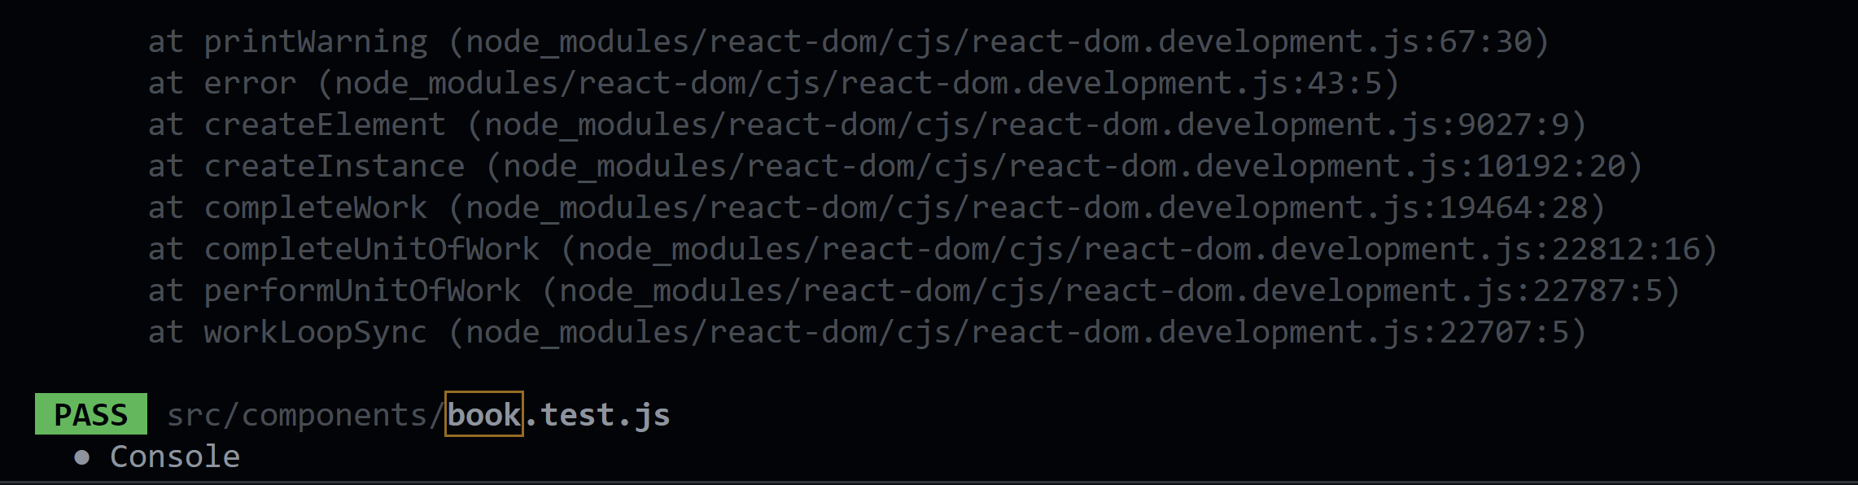

import { render ,screen , cleanup } from '@testing-library/react';

import Books from './books';

it('renders without crashing', () => {

    render(<Books />);

    cleanup();

});

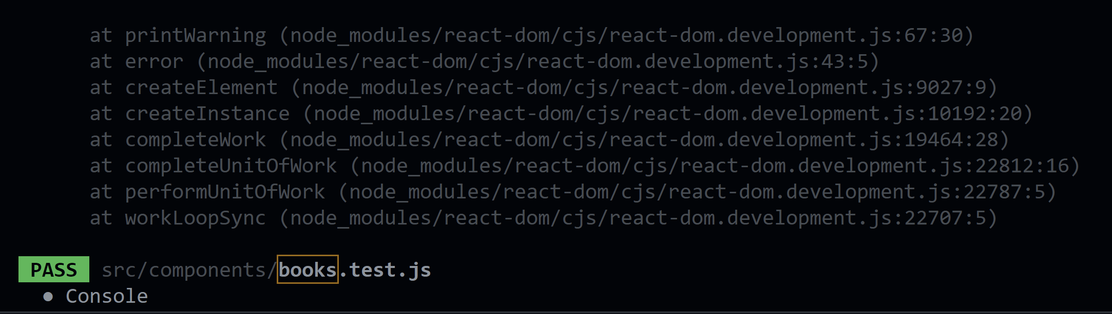

import React from "react";

import ReactDOM from "react-dom";

import contact from "./Contact";

it("renders without crashing", () => {

    const div = document.createElement("div");

    ReactDOM.render(<contact />, div);

} );

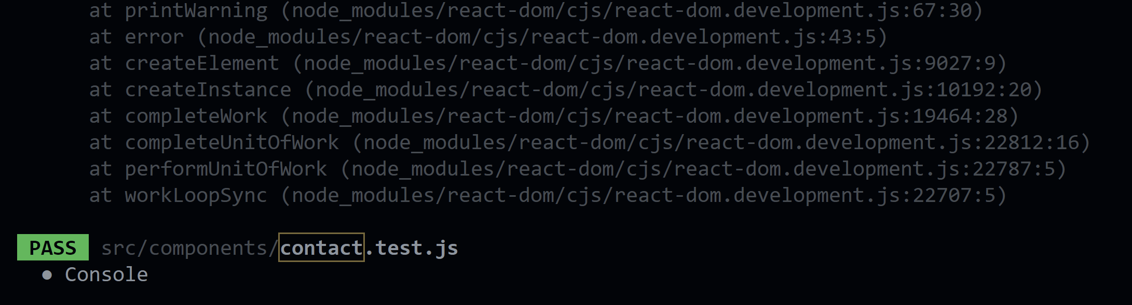

import React from "react";

import ReactDOM from "react-dom";

import faq from "./Faq";

it("renders without crashing", () => {

    const div = document.createElement("div");

    ReactDOM.render(<faq />, div);

} );

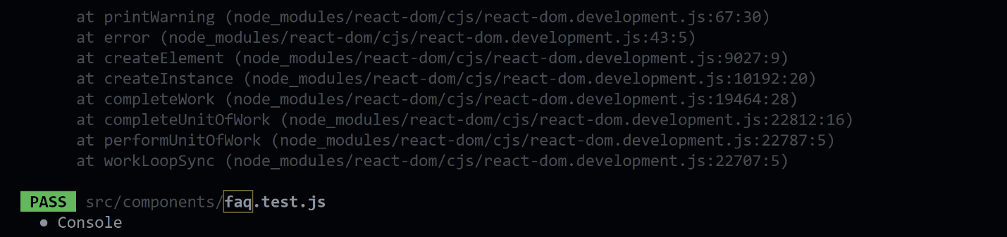

import React from "react";

import ReactDOM from "react-dom";

import scrollToTop from "./home";

it("renders scroll to top without crashing", () => {

    const div = document.createElement("div");

    ReactDOM.render(<scorllToTop />, div);

});

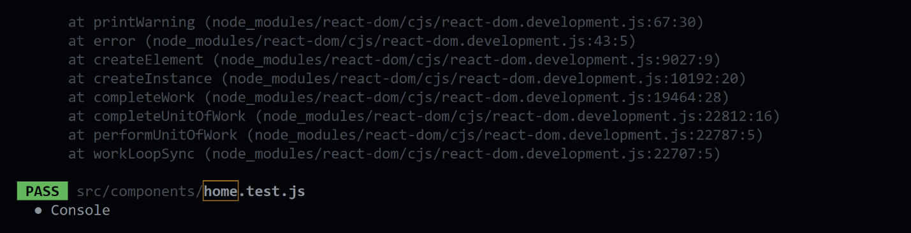

import { isValidTimestamp } from "@firebase/util";

import React from "react";

import  ReactDOM  from "react-dom";

import navbar from "./navbar";

import { render } from "@testing-library/react"

it("renders without crashing", () => {

  const div = document.createElement("div");

  ReactDOM.render(<navbar />, div);

});

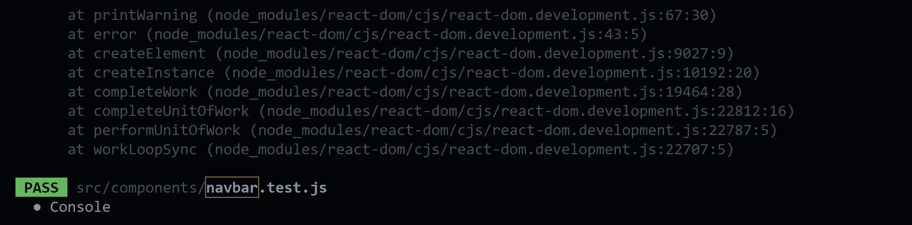

**7.3] UI Testing**

**Tool Used: Katalon Studio**

**Web app:**

**1] Login page**

**CODE:**

import static com.kms.katalon.core.checkpoint.CheckpointFactory.findCheckpoint

import static com.kms.katalon.core.testcase.TestCaseFactory.findTestCase

import static com.kms.katalon.core.testdata.TestDataFactory.findTestData

import static com.kms.katalon.core.testobject.ObjectRepository.findTestObject

import static com.kms.katalon.core.testobject.ObjectRepository.findWindowsObject

import com.kms.katalon.core.checkpoint.Checkpoint as Checkpoint

import com.kms.katalon.core.cucumber.keyword.CucumberBuiltinKeywords as CucumberKW

import com.kms.katalon.core.mobile.keyword.MobileBuiltInKeywords as Mobile

import com.kms.katalon.core.model.FailureHandling as FailureHandling

import com.kms.katalon.core.testcase.TestCase as TestCase

import com.kms.katalon.core.testdata.TestData as TestData

import com.kms.katalon.core.testng.keyword.TestNGBuiltinKeywords as TestNGKW

import com.kms.katalon.core.testobject.TestObject as TestObject

import com.kms.katalon.core.webservice.keyword.WSBuiltInKeywords as WS

import com.kms.katalon.core.webui.keyword.WebUiBuiltInKeywords as WebUI

import com.kms.katalon.core.windows.keyword.WindowsBuiltinKeywords as Windows

import internal.GlobalVariable as GlobalVariable

import org.openqa.selenium.Keys as Keys

WebUI.openBrowser('')

WebUI.navigateToUrl('http://localhost:3000/')

WebUI.click(findTestObject('Object Repository/login/Page_E-Library/button_Login'))

WebUI.setText(findTestObject('Object Repository/login/Page_E-Library/input_Login_form-control formc'), 'cb.en.u4cse19318')

WebUI.setEncryptedText(findTestObject('Object Repository/login/Page_E-Library/input_Login_form-control formc_1'), 'aeHFOx8jV/A=')

WebUI.click(findTestObject('Object Repository/login/Page_E-Library/button_Log In'))

WebUI.setText(findTestObject('Object Repository/login/Page_E-Library/input_Login_form-control formc'), 'cb.en.u4cse19318@cb.students.amrita.edu')

WebUI.setEncryptedText(findTestObject('Object Repository/login/Page_E-Library/input_Login_form-control formc_1'), 'qeJ0sjJnwEs=')

WebUI.click(findTestObject('Object Repository/login/Page_E-Library/button_Log In'))

WebUI.setEncryptedText(findTestObject('Object Repository/login/Page_E-Library/input_Login_form-control formc_1'), 'aeHFOx8jV/A=')

WebUI.click(findTestObject('Object Repository/login/Page_E-Library/button_Log In'))

WebUI.click(findTestObject('Object Repository/login/Page_E-Library/input'))

WebUI.click(findTestObject('Object Repository/login/Page_E-Library/button_LogOut'))

**SCANNING:**

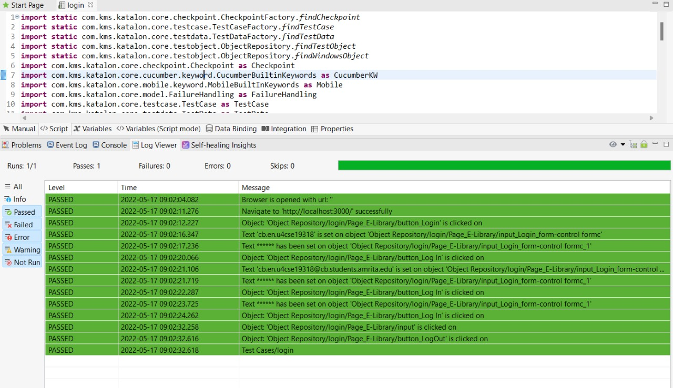

**OUTPUT:**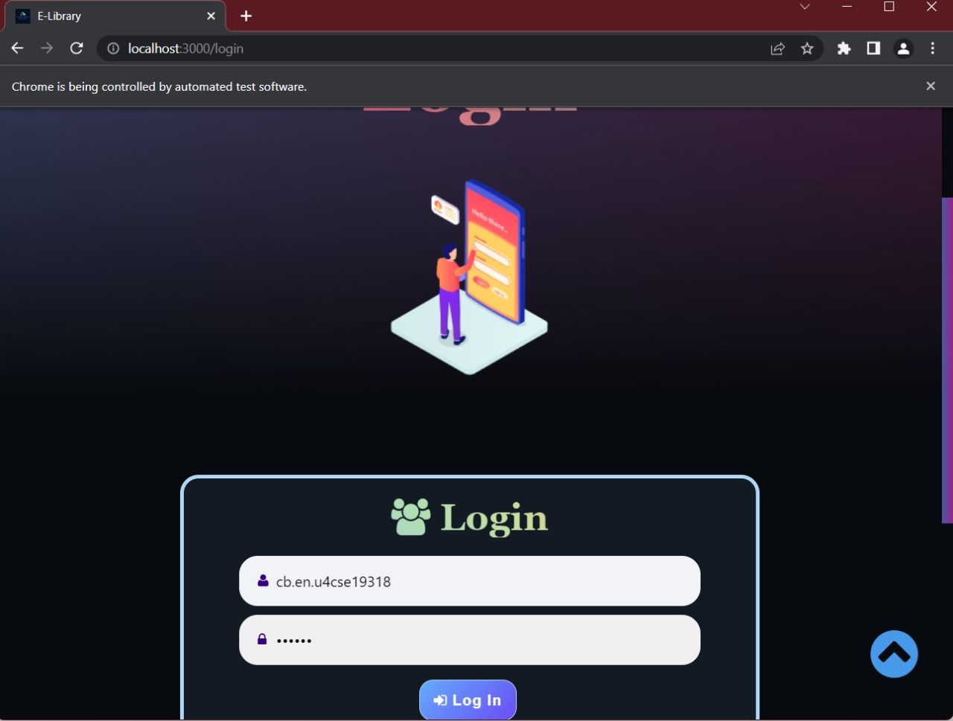

**2] OPAC_Search**

**CODE:**

import static com.kms.katalon.core.checkpoint.CheckpointFactory.findCheckpoint

import static com.kms.katalon.core.testcase.TestCaseFactory.findTestCase

import static com.kms.katalon.core.testdata.TestDataFactory.findTestData

import static com.kms.katalon.core.testobject.ObjectRepository.findTestObject

import static com.kms.katalon.core.testobject.ObjectRepository.findWindowsObject

import com.kms.katalon.core.checkpoint.Checkpoint as Checkpoint

import com.kms.katalon.core.cucumber.keyword.CucumberBuiltinKeywords as CucumberKW

import com.kms.katalon.core.mobile.keyword.MobileBuiltInKeywords as Mobile

import com.kms.katalon.core.model.FailureHandling as FailureHandling

import com.kms.katalon.core.testcase.TestCase as TestCase

import com.kms.katalon.core.testdata.TestData as TestData

import com.kms.katalon.core.testng.keyword.TestNGBuiltinKeywords as TestNGKW

import com.kms.katalon.core.testobject.TestObject as TestObject

import com.kms.katalon.core.webservice.keyword.WSBuiltInKeywords as WS

import com.kms.katalon.core.webui.keyword.WebUiBuiltInKeywords as WebUI

import com.kms.katalon.core.windows.keyword.WindowsBuiltinKeywords as Windows

import internal.GlobalVariable as GlobalVariable

import org.openqa.selenium.Keys as Keys

WebUI.openBrowser('')

WebUI.navigateToUrl('http://localhost:3000/')

WebUI.click(findTestObject('Object Repository/search_Opac/Page_E-Library/b_OPAC'))

WebUI.setText(findTestObject('Object Repository/search_Opac/Page_E-Library/input_OPAC_searchInput1'), 'harry')

WebUI.click(findTestObject('Object Repository/search_Opac/Page_E-Library/button_OPAC_searchButton1'))

WebUI.click(findTestObject('Object Repository/search_Opac/Page_E-Library/div_Playing Harry PotterAuthor Lisa S. Bren_b5ecbf'))

WebUI.setText(findTestObject('Object Repository/search_Opac/Page_E-Library/input_OPAC_searchInput1'), 'harry potter')

WebUI.click(findTestObject('Object Repository/search_Opac/Page_E-Library/i_OPAC_fa fa-search'))

WebUI.selectOptionByValue(findTestObject('Object Repository/search_Opac/Page_E-Library/select_SortNewestOldest'), 'Newest',

true)

WebUI.click(findTestObject('Object Repository/search_Opac/Page_E-Library/button_Details'))

WebUI.switchToWindowTitle('E-Library')

WebUI.click(findTestObject('Object Repository/search_Opac/Page_E-Library/button_Read Now'))

WebUI.switchToWindowTitle('E-Library')

WebUI.click(findTestObject('Object Repository/search_Opac/Page_E-Library/button_BookList'))

**Scanning:**

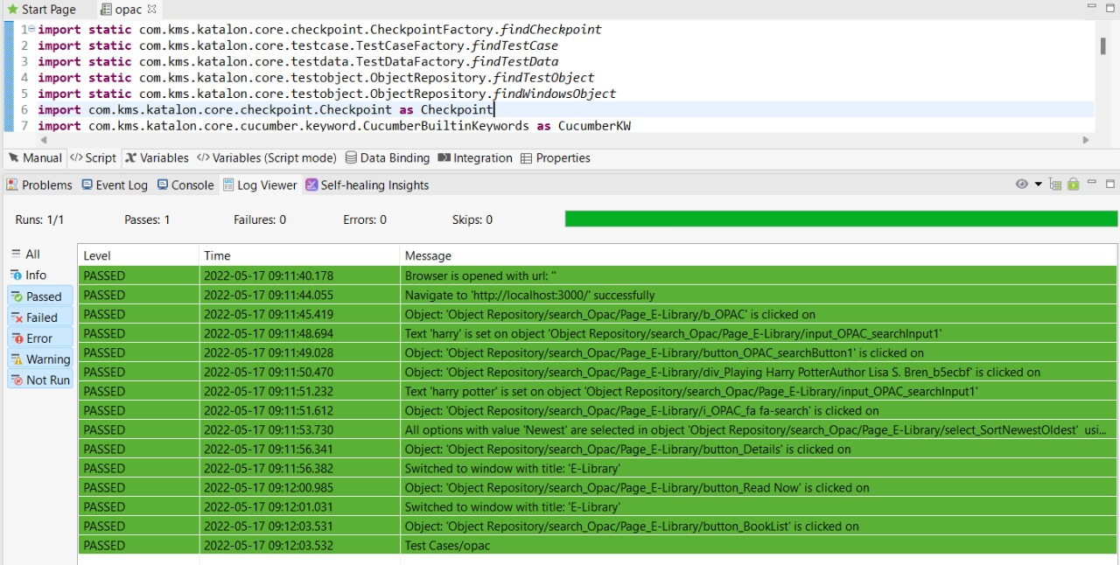

**Output:**

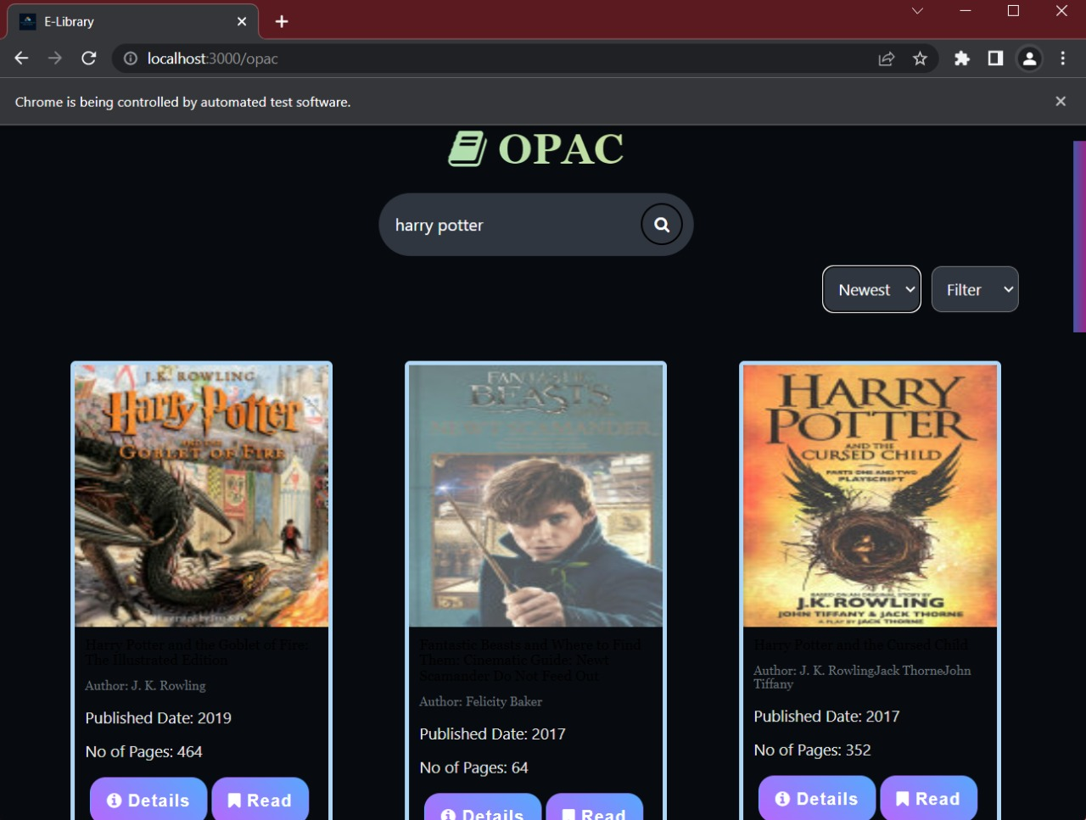

**3] Profile-edit**

**Code:**

import static com.kms.katalon.core.checkpoint.CheckpointFactory.findCheckpoint

import static com.kms.katalon.core.testcase.TestCaseFactory.findTestCase

import static com.kms.katalon.core.testdata.TestDataFactory.findTestData

import static com.kms.katalon.core.testobject.ObjectRepository.findTestObject

import static com.kms.katalon.core.testobject.ObjectRepository.findWindowsObject

import com.kms.katalon.core.checkpoint.Checkpoint as Checkpoint

import com.kms.katalon.core.cucumber.keyword.CucumberBuiltinKeywords as CucumberKW

import com.kms.katalon.core.mobile.keyword.MobileBuiltInKeywords as Mobile

import com.kms.katalon.core.model.FailureHandling as FailureHandling

import com.kms.katalon.core.testcase.TestCase as TestCase

import com.kms.katalon.core.testdata.TestData as TestData

import com.kms.katalon.core.testng.keyword.TestNGBuiltinKeywords as TestNGKW

import com.kms.katalon.core.testobject.TestObject as TestObject

import com.kms.katalon.core.webservice.keyword.WSBuiltInKeywords as WS

import com.kms.katalon.core.webui.keyword.WebUiBuiltInKeywords as WebUI

import com.kms.katalon.core.windows.keyword.WindowsBuiltinKeywords as Windows

import internal.GlobalVariable as GlobalVariable

import org.openqa.selenium.Keys as Keys

WebUI.openBrowser('')

WebUI.navigateToUrl('http://localhost:3000/')

WebUI.click(findTestObject('Object Repository/profilepage/Page_E-Library/button_Login'))

WebUI.setText(findTestObject('Object Repository/profilepage/Page_E-Library/input_Login_form-control formc'), 'cb.en.u4cse19318@cb.students.amrita.edu')

WebUI.setEncryptedText(findTestObject('Object Repository/profilepage/Page_E-Library/input_Login_form-control formc_1'),

'aeHFOx8jV/A=')

WebUI.click(findTestObject('Object Repository/profilepage/Page_E-Library/button_Log In'))

WebUI.click(findTestObject('Object Repository/profilepage/Page_E-Library/input'))

WebUI.click(findTestObject('Object Repository/profilepage/Page_E-Library/span_OPAC_fa fa-user'))

WebUI.click(findTestObject('Object Repository/profilepage/Page_E-Library/button_Edit'))

WebUI.click(findTestObject('Object Repository/profilepage/Page_E-Library/input_First Name_fnam'))

WebUI.setText(findTestObject('Object Repository/profilepage/Page_E-Library/input_First Name_fnam_1'), 'D')

WebUI.setText(findTestObject('Object Repository/profilepage/Page_E-Library/input_First Name_fnam_1_2'), 'Dh')

WebUI.setText(findTestObject('Object Repository/profilepage/Page_E-Library/input_First Name_fnam_1_2_3'), 'Dha')

WebUI.setText(findTestObject('Object Repository/profilepage/Page_E-Library/input_First Name_fnam_1_2_3_4'), 'Dhar')

WebUI.setText(findTestObject('Object Repository/profilepage/Page_E-Library/input_First Name_fnam_1_2_3_4_5'), 'Dharu')

WebUI.setText(findTestObject('Object Repository/profilepage/Page_E-Library/input_First Name_fnam_1_2_3_4_5_6'), 'Dharun')

WebUI.setText(findTestObject('Object Repository/profilepage/Page_E-Library/input_First Name_fnam_1_2_3_4_5_6_7'), 'Dharun ')

WebUI.setText(findTestObject('Object Repository/profilepage/Page_E-Library/input_First Name_fnam_1_2_3_4_5_6_7_8'), 'Dharun N')

WebUI.setText(findTestObject('Object Repository/profilepage/Page_E-Library/input_First Name_fnam_1_2_3_4_5_6_7_8_9'), 'Dharun Na')

WebUI.setText(findTestObject('Object Repository/profilepage/Page_E-Library/input_First Name_fnam_1_2_3_4_5_6_7_8_9_10'),

'Dharun Nar')

WebUI.setText(findTestObject('Object Repository/profilepage/Page_E-Library/input_First Name_fnam_1_2_3_4_5_6_7_8_9_10_11'),

'Dharun Nara')

WebUI.setText(findTestObject('Object Repository/profilepage/Page_E-Library/input_First Name_fnam_1_2_3_4_5_6_7_8_9_10_11_12'),

'Dharun Naray')

WebUI.setText(findTestObject('Object Repository/profilepage/Page_E-Library/input_First Name_fnam_1_2_3_4_5_6_7_8_9_10_11_12_13'),

'Dharun Naraya')

WebUI.setText(findTestObject('Object Repository/profilepage/Page_E-Library/input_First Name_fnam_1_2_3_4_5_6_7_8_9_10_11_12_13_14'),

'Dharun Narayan')

WebUI.setText(findTestObject('Object Repository/profilepage/Page_E-Library/input_First Name_fnam_1_2_3_4_5_6_7_8_9_10_11_12_13_14_15'),

'Dharun Narayana')

WebUI.setText(findTestObject('Object Repository/profilepage/Page_E-Library/input_First Name_fnam_1_2_3_4_5_6_7_8_9_10_11_12_13_14_15_16'),

'Dharun Narayanan')

WebUI.click(findTestObject('Object Repository/profilepage/Page_E-Library/input_Last Name_lnam'))

WebUI.setText(findTestObject('Object Repository/profilepage/Page_E-Library/input_Last Name_lnam_1'), 'L')

WebUI.setText(findTestObject('Object Repository/profilepage/Page_E-Library/input_Last Name_lnam_1_2'), 'L ')

WebUI.setText(findTestObject('Object Repository/profilepage/Page_E-Library/input_Last Name_lnam'), 'L K')

WebUI.click(findTestObject('Object Repository/profilepage/Page_E-Library/input_Phone_fnam'))

WebUI.setText(findTestObject('Object Repository/profilepage/Page_E-Library/input_Phone_fnam_1'), '9')

WebUI.setText(findTestObject('Object Repository/profilepage/Page_E-Library/input_Phone_fnam_1_2'), '95')

WebUI.setText(findTestObject('Object Repository/profilepage/Page_E-Library/input_Phone_fnam_1_2_3'), '959')

WebUI.setText(findTestObject('Object Repository/profilepage/Page_E-Library/input_Phone_fnam_1_2_3_4'), '9597')

WebUI.setText(findTestObject('Object Repository/profilepage/Page_E-Library/input_Phone_fnam_1_2_3_4_5'), '95973')

WebUI.setText(findTestObject('Object Repository/profilepage/Page_E-Library/input_Phone_fnam_1_2_3_4_5_6'), '959734')

WebUI.setText(findTestObject('Object Repository/profilepage/Page_E-Library/input_Phone_fnam_1_2_3_4_5_6_7'), '9597342')

WebUI.setText(findTestObject('Object Repository/profilepage/Page_E-Library/input_Phone_fnam_1_2_3_4_5_6_7_8'), '95973423')

WebUI.setText(findTestObject('Object Repository/profilepage/Page_E-Library/input_Phone_fnam_1_2_3_4_5_6_7_8_9'), '959734234')

WebUI.setText(findTestObject('Object Repository/profilepage/Page_E-Library/input_Phone_fnam_1_2_3_4_5_6_7_8_9_10'), '9597342348')

WebUI.click(findTestObject('Object Repository/profilepage/Page_E-Library/button_Save'))

WebUI.click(findTestObject('Object Repository/profilepage/Page_E-Library/button_Back'))

WebUI.click(findTestObject('Object Repository/profilepage/Page_E-Library/button_LogOut'))

**Scanning:**

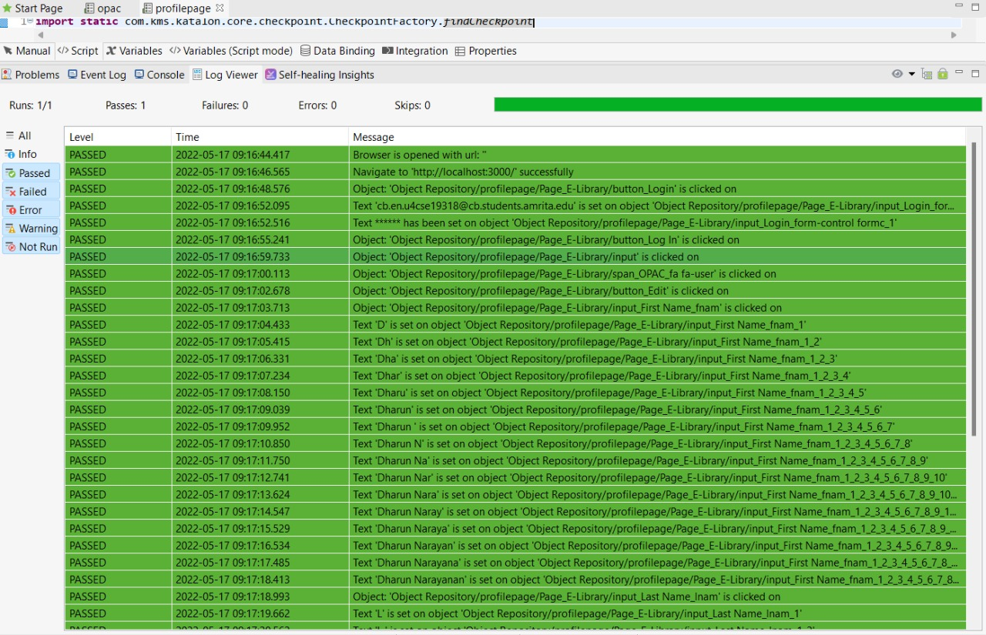

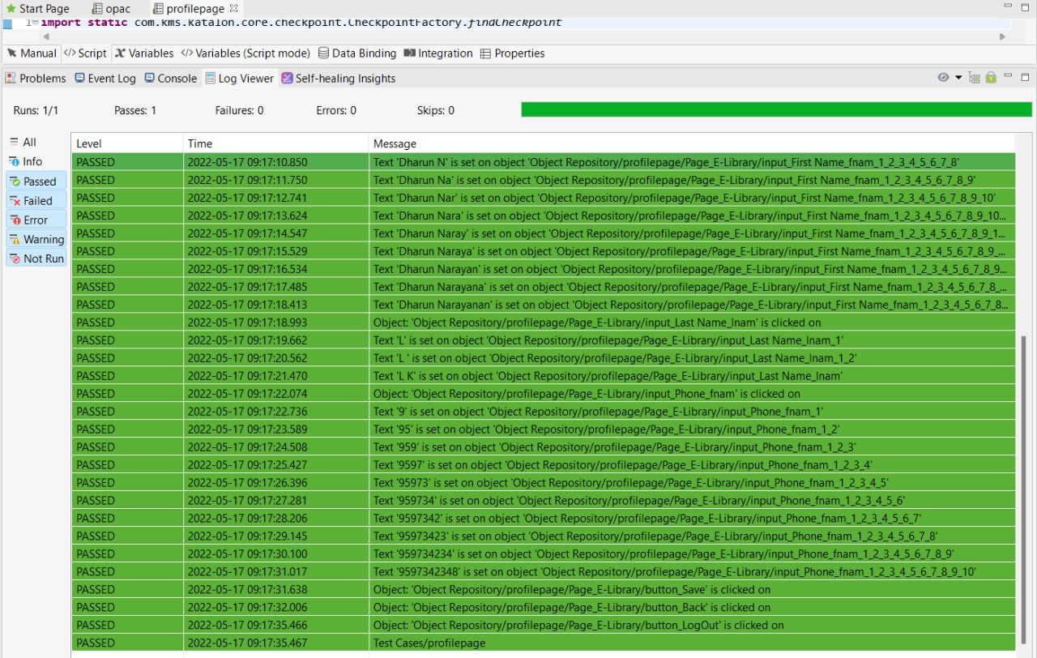

**Output:**

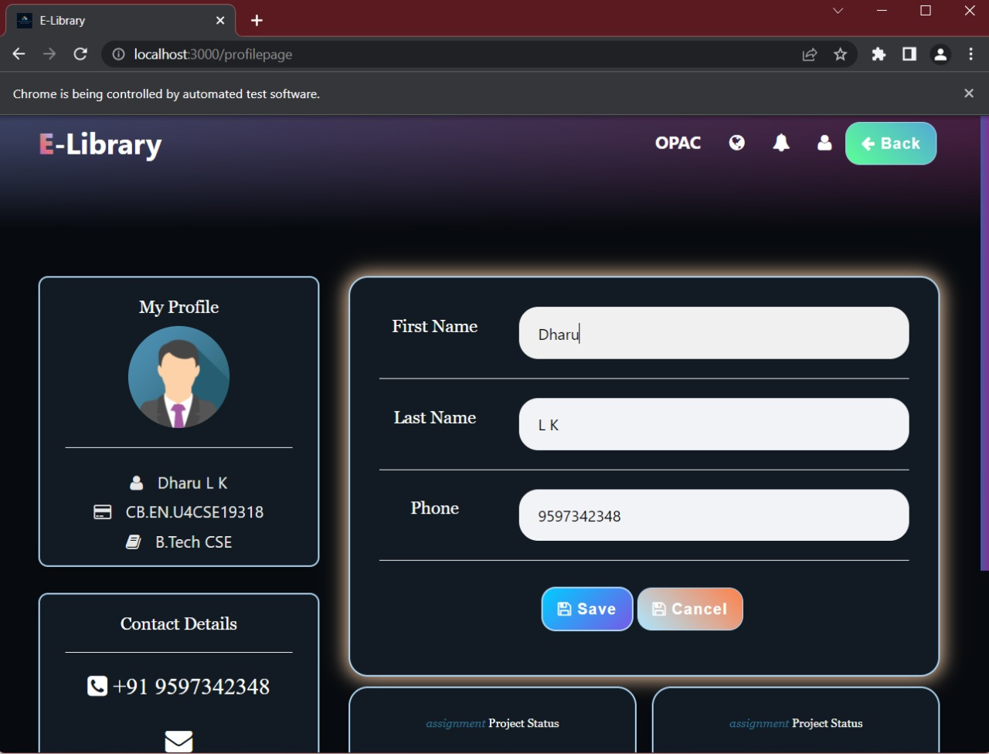

**4] Contact us**

**Code:**

import static com.kms.katalon.core.checkpoint.CheckpointFactory.findCheckpoint

import static com.kms.katalon.core.testcase.TestCaseFactory.findTestCase

import static com.kms.katalon.core.testdata.TestDataFactory.findTestData

import static com.kms.katalon.core.testobject.ObjectRepository.findTestObject

import static com.kms.katalon.core.testobject.ObjectRepository.findWindowsObject

import com.kms.katalon.core.checkpoint.Checkpoint as Checkpoint

import com.kms.katalon.core.cucumber.keyword.CucumberBuiltinKeywords as CucumberKW

import com.kms.katalon.core.mobile.keyword.MobileBuiltInKeywords as Mobile

import com.kms.katalon.core.model.FailureHandling as FailureHandling

import com.kms.katalon.core.testcase.TestCase as TestCase

import com.kms.katalon.core.testdata.TestData as TestData

import com.kms.katalon.core.testng.keyword.TestNGBuiltinKeywords as TestNGKW

import com.kms.katalon.core.testobject.TestObject as TestObject

import com.kms.katalon.core.webservice.keyword.WSBuiltInKeywords as WS

import com.kms.katalon.core.webui.keyword.WebUiBuiltInKeywords as WebUI

import com.kms.katalon.core.windows.keyword.WindowsBuiltinKeywords as Windows

import internal.GlobalVariable as GlobalVariable

import org.openqa.selenium.Keys as Keys

WebUI.openBrowser('')

WebUI.navigateToUrl('http://localhost:3000/')

WebUI.click(findTestObject('Object Repository/contact/Page_E-Library/b_Contact'))

WebUI.setText(findTestObject('Object Repository/contact/Page_E-Library/input_Your name_name'), 'Test User')

WebUI.setText(findTestObject('Object Repository/contact/Page_E-Library/input_Your email_email'), 'lkdharun26@gmail.com')

WebUI.setText(findTestObject('Object Repository/contact/Page_E-Library/input_Subject_subject'), 'Test')

WebUI.setText(findTestObject('Object Repository/contact/Page_E-Library/textarea_Your message_message'), 'Abstract')

WebUI.click(findTestObject('Object Repository/contact/Page_E-Library/input_Send_contact_to'))

WebUI.click(findTestObject('Object Repository/contact/Page_E-Library/button_Send'))

WebUI.closeBrowser()

**Scanning:**

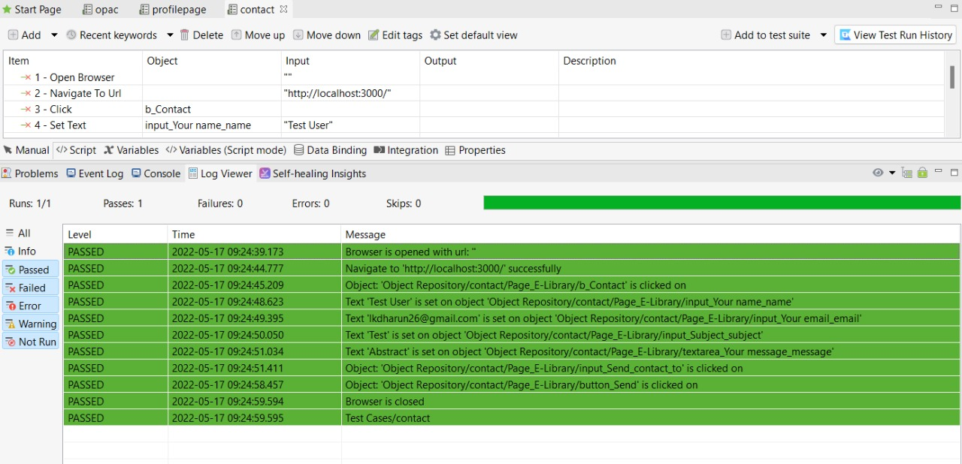

**Output:**

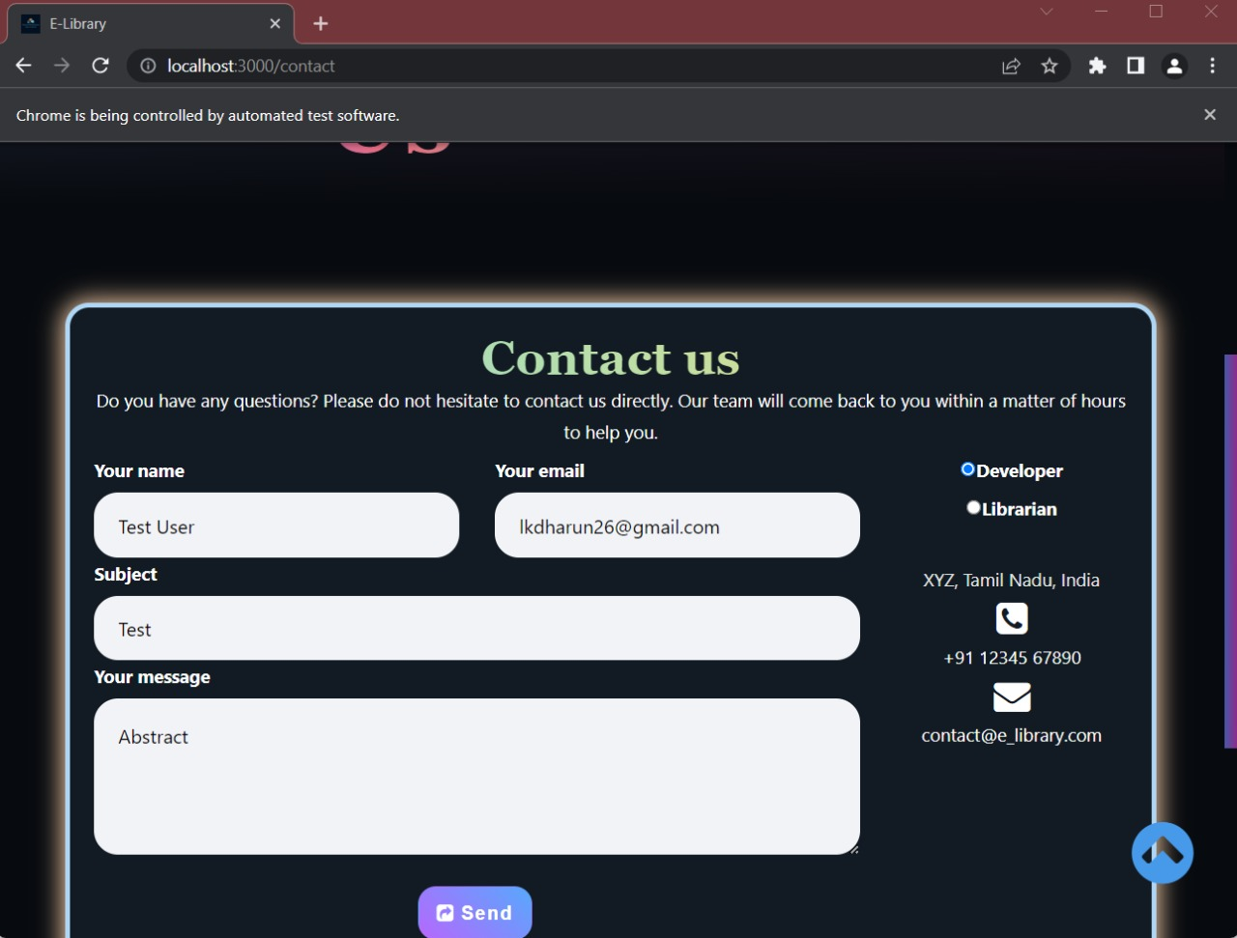

**Mobile App:**

UI Testing done using Junit4 and Espresso.

**1.**MainActivityTest – Activity

CODE:

package com.example.library_automation;  
  
import static androidx.test.espresso.action.ViewActions.*click*;  
import static androidx.test.espresso.action.ViewActions.*typeText*;  
import static androidx.test.espresso.assertion.ViewAssertions.*matches*;  
import static androidx.test.espresso.matcher.ViewMatchers.*withId*;  
import static androidx.test.espresso.matcher.ViewMatchers.*withText*;  
import static org.junit.Assert.*;  
  
import android.view.View;  
  
import androidx.test.espresso.Espresso;  
import androidx.test.rule.ActivityTestRule;  
  
import org.junit.After;  
import org.junit.Before;  
import org.junit.Rule;  
import org.junit.Test;  
  
public class MainActivityTest {  
  
 @Rule  
 public ActivityTestRule<MainActivity> mActivityTestRule = new ActivityTestRule<MainActivity>(MainActivity.class);  
 *//private String name = "John";* private MainActivity mActivity = null;  
 @Before  
 public void setUp() throws Exception {  
 mActivity = mActivityTestRule.getActivity();  
 }  
  
 @Test  
 public void testLaunch(){  
 View view = mActivity.findViewById(R.id.*wel*);  
  
 *assertNotNull*(view);  
 }  
 */*@Test  
 public void testUserInput(){  
 Espresso.onView(withId(R.id.en)).perform(typeText(name));  
 Espresso.onView(withId(R.id.btn_update)).perform(click());  
 Espresso.onView(withId(R.id.en)).check(matches(withText(name)));  
 }*/* @After  
 public void tearDown() throws Exception {  
 mActivity = null;  
 }  
}

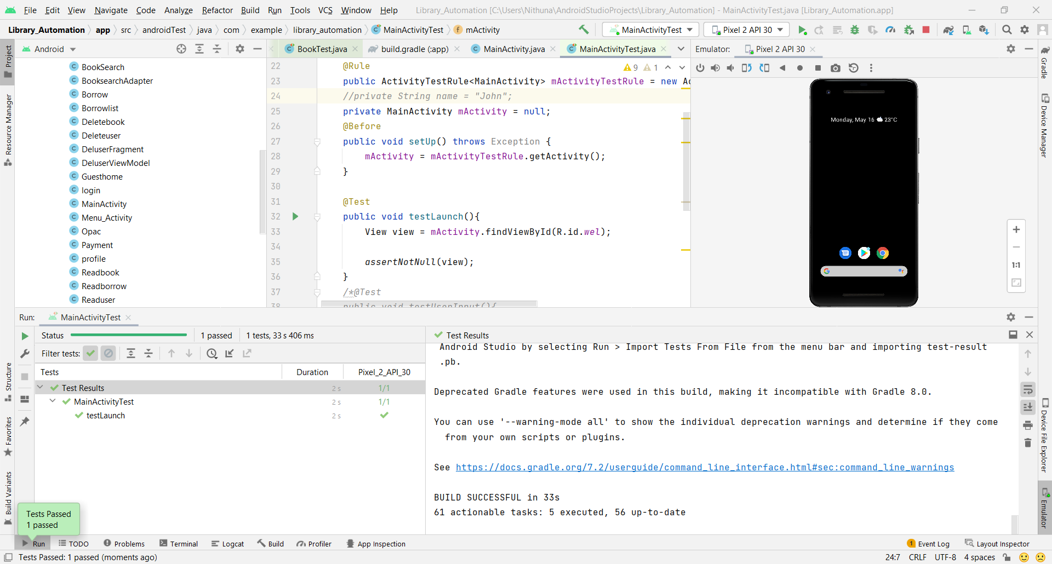

**2.**AdduserTest – Activity

CODE:

package com.example.library_automation;  
  
import static androidx.test.espresso.action.ViewActions.*click*;  
import static androidx.test.espresso.action.ViewActions.*typeText*;  
import static androidx.test.espresso.assertion.ViewAssertions.*matches*;  
import static androidx.test.espresso.matcher.ViewMatchers.*withId*;  
import static androidx.test.espresso.matcher.ViewMatchers.*withText*;  
import org.junit.Test;  
import static org.junit.Assert.*;  
  
import android.view.View;  
  
import androidx.test.espresso.Espresso;  
import androidx.test.espresso.ViewAction;  
import androidx.test.rule.ActivityTestRule;  
  
import org.junit.After;  
import org.junit.Before;  
import org.junit.Rule;  
*//import org.junit.jupiter.api.Test;*public class AdduserTest {  
  
 @Rule  
 public ActivityTestRule<Adduser> mActivityTestRule = new ActivityTestRule<Adduser>(Adduser.class);  
 private String name = "User Details";  
 private Adduser mActivity = null;  
  
 @Before  
 public void setUp() throws Exception {  
 mActivity = mActivityTestRule.getActivity();  
 }  
  
 @Test  
 public void testUserInput(){  
 Espresso.*onView*(*withId*(R.id.*adduser*)).perform(*click*());  
 Espresso.*onView*(*withId*(R.id.*ud*)).check(*matches*(*withText*(name)));  
 }  
  
 @Test  
 public void testLaunch(){  
 View view = mActivity.findViewById(R.id.*ud*);  
 *assertNotNull*(view);  
 }  
  
 @After  
 public void tearDown() throws Exception {  
 mActivity = null;  
 }  
}

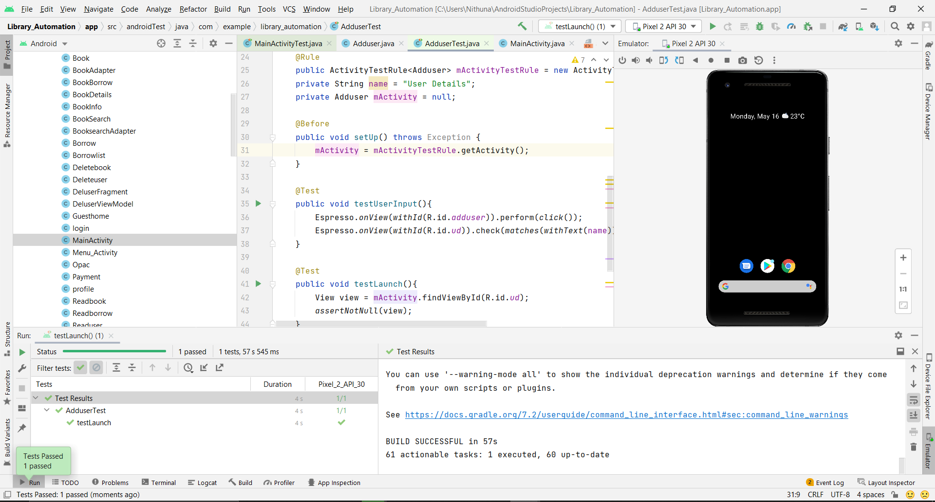

**8] PROJECT SCREENSHOTS**

**Mobile Application:**

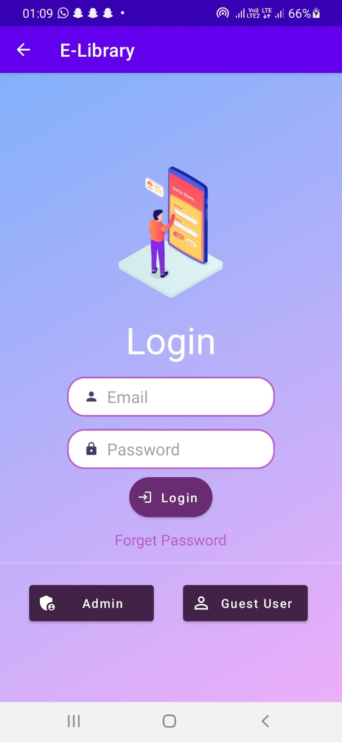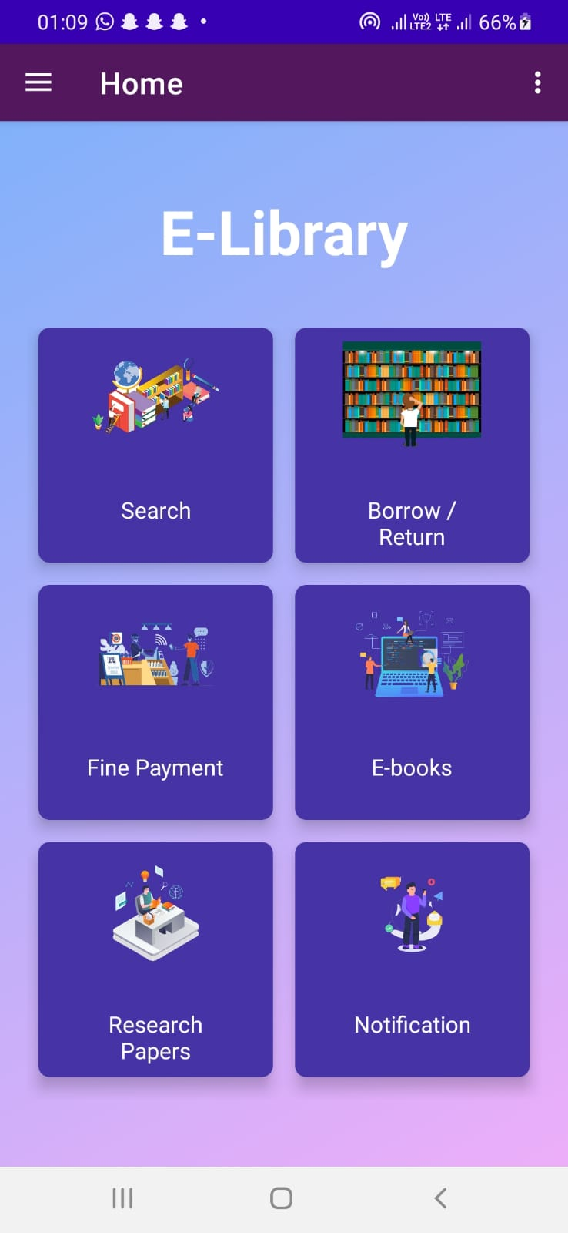

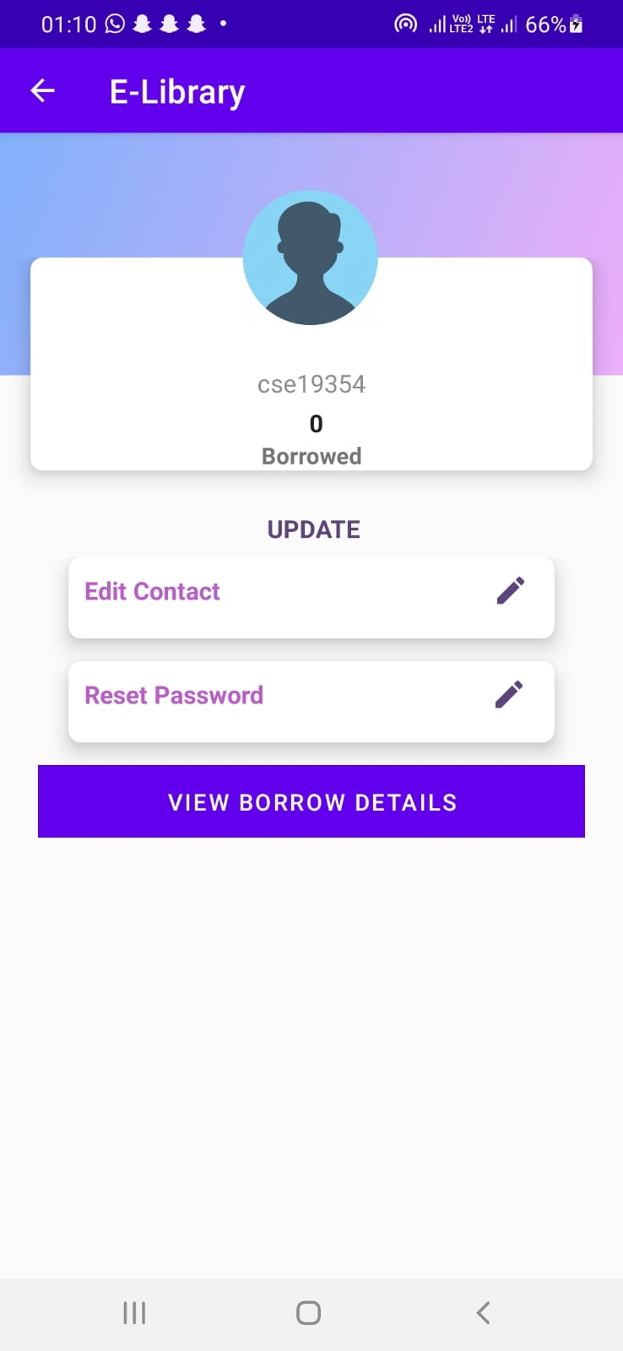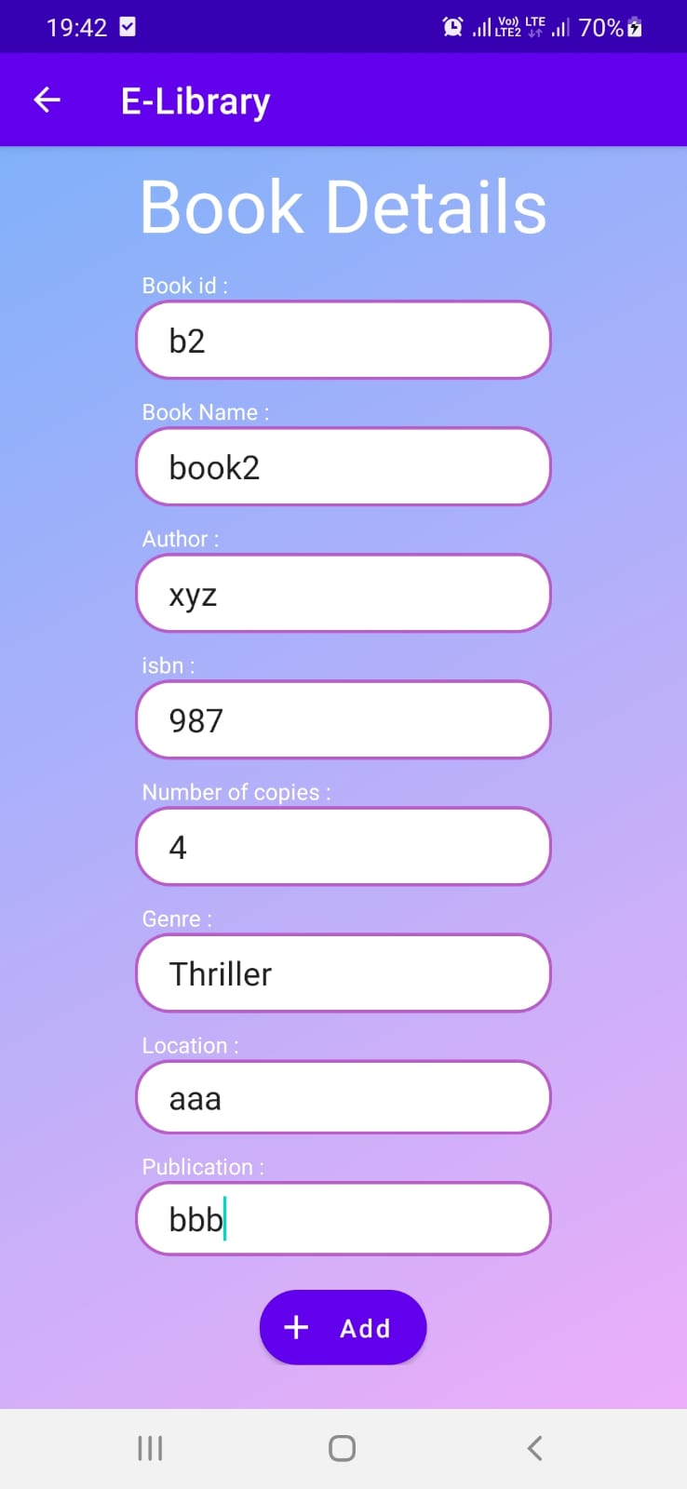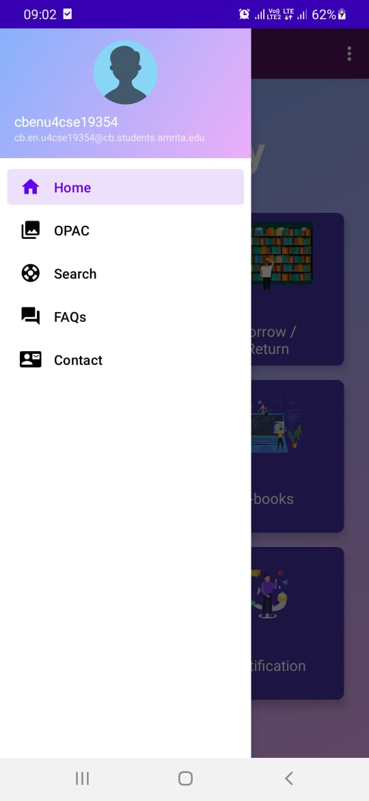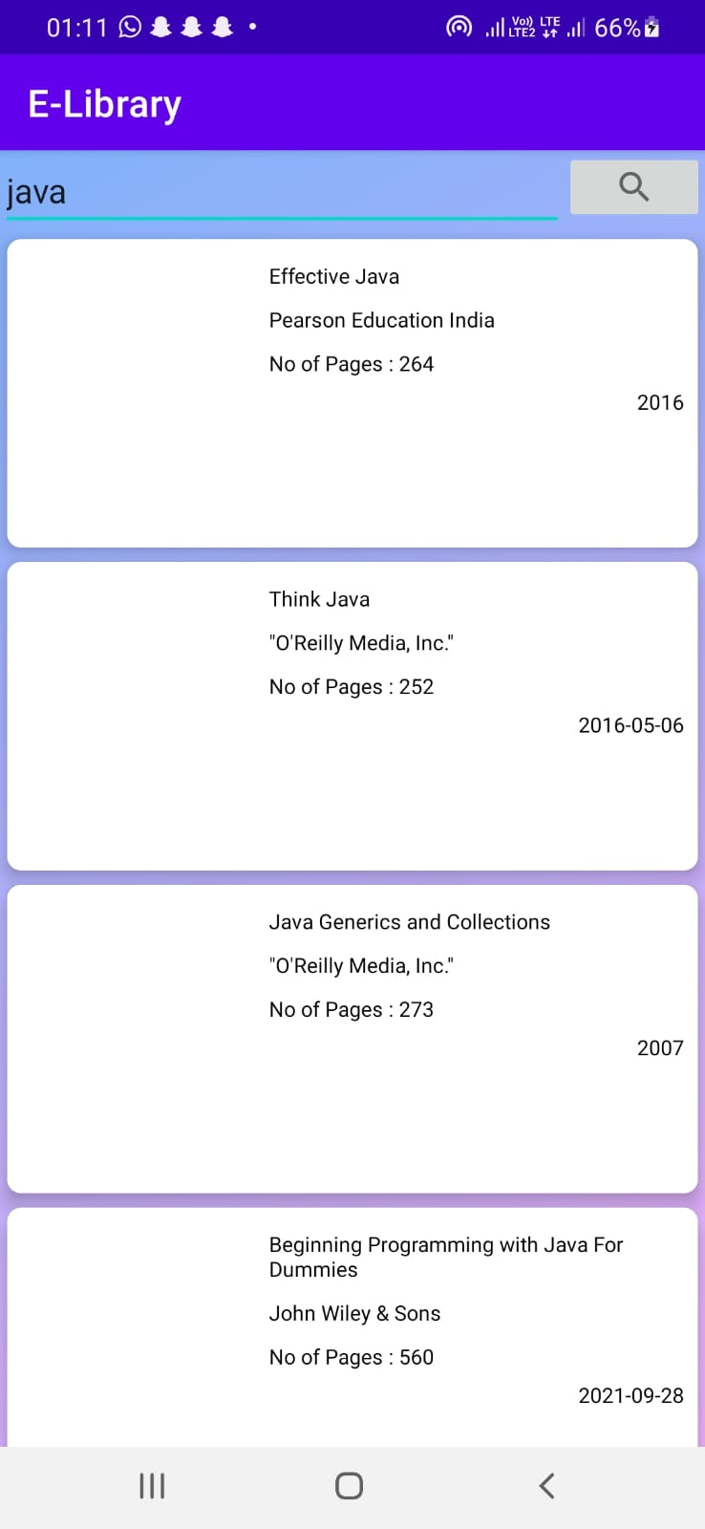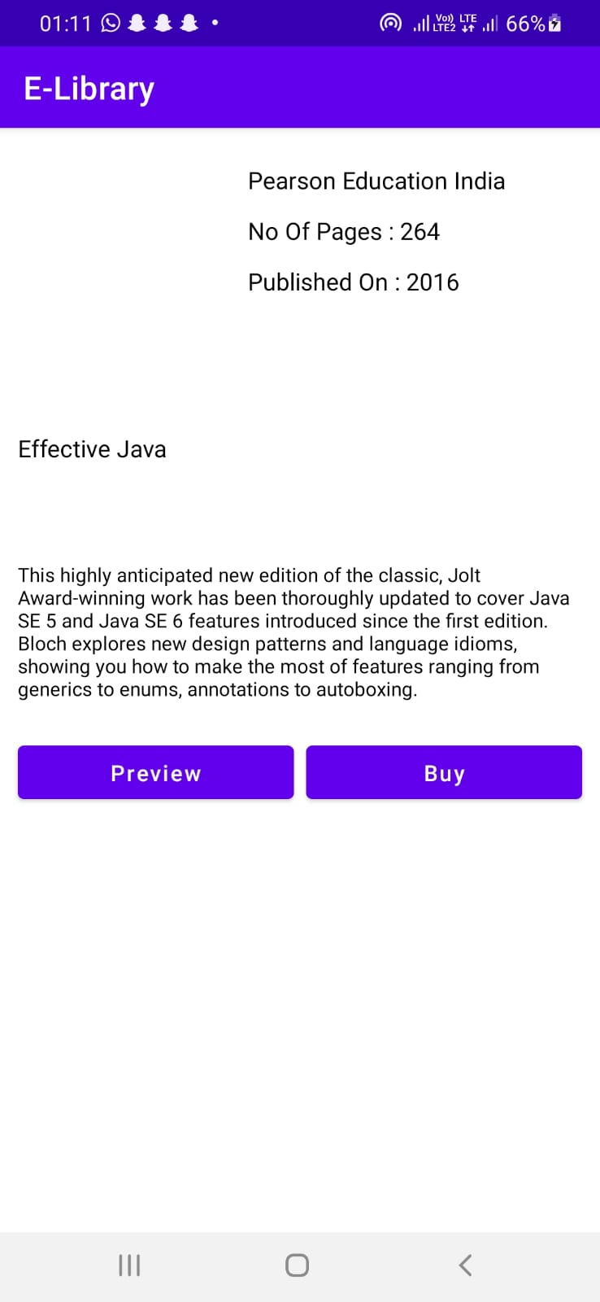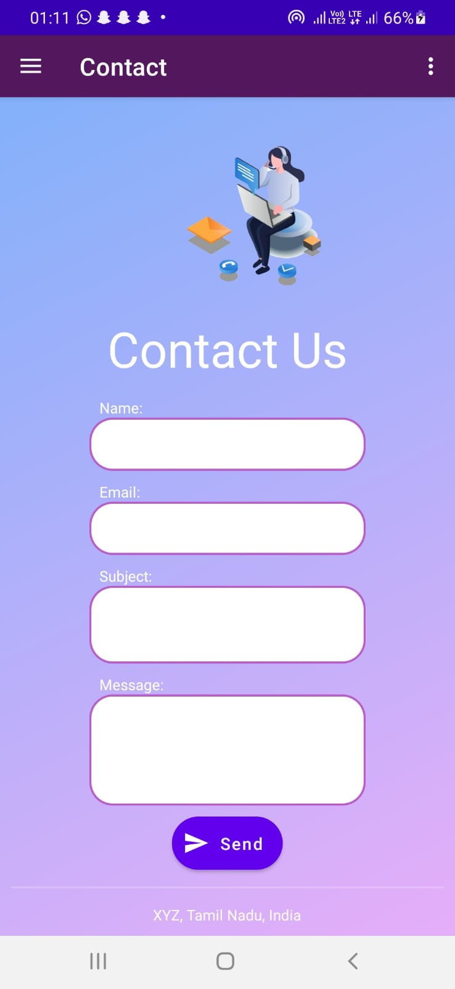

**Web Application:**

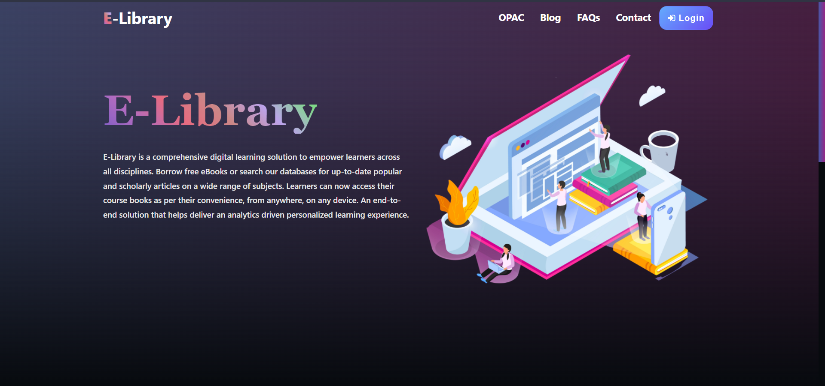

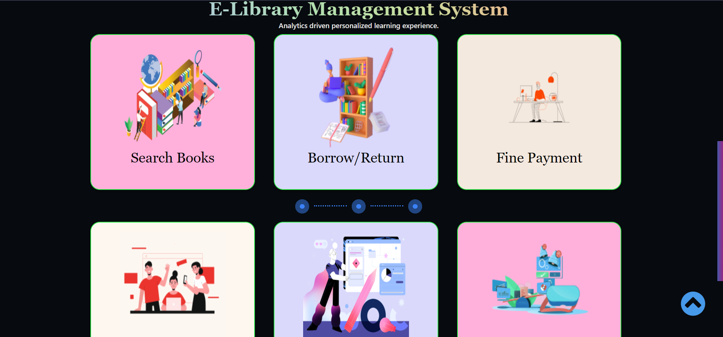

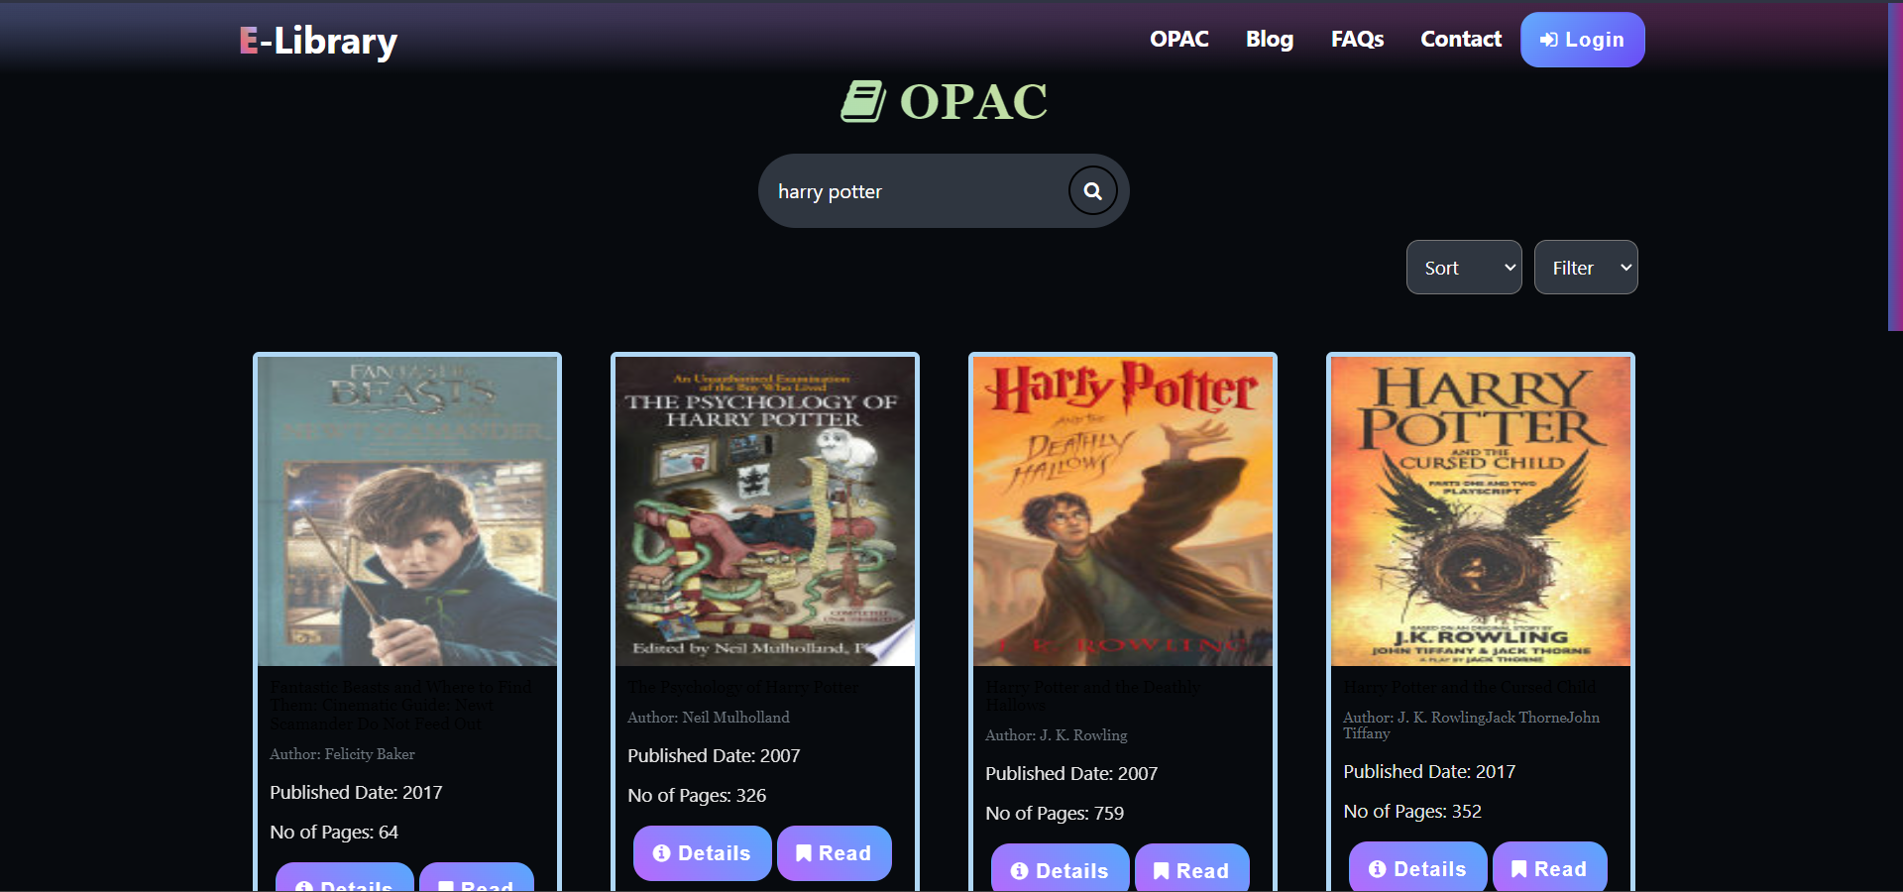

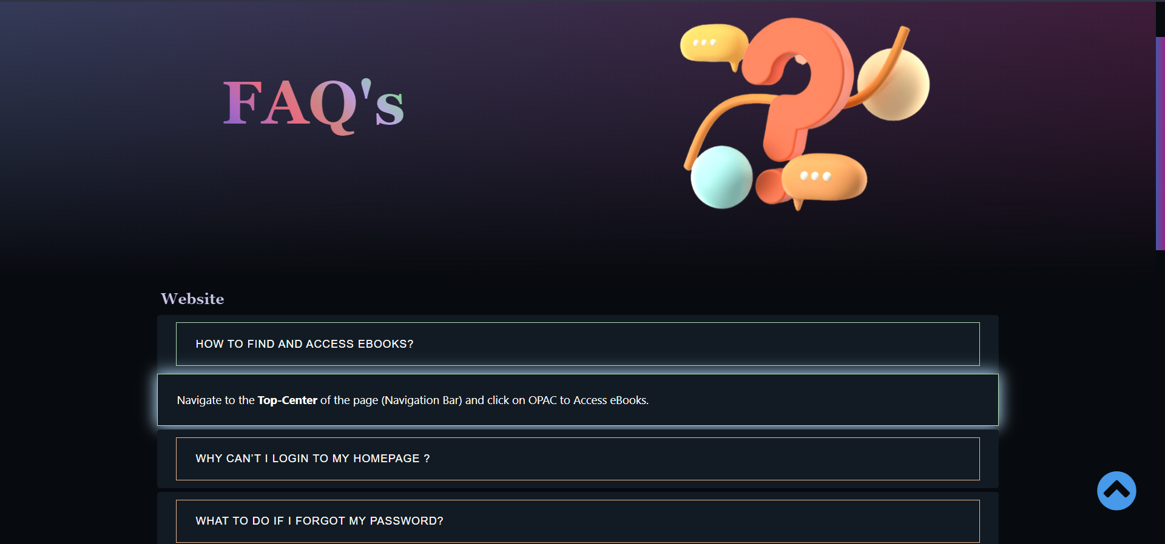

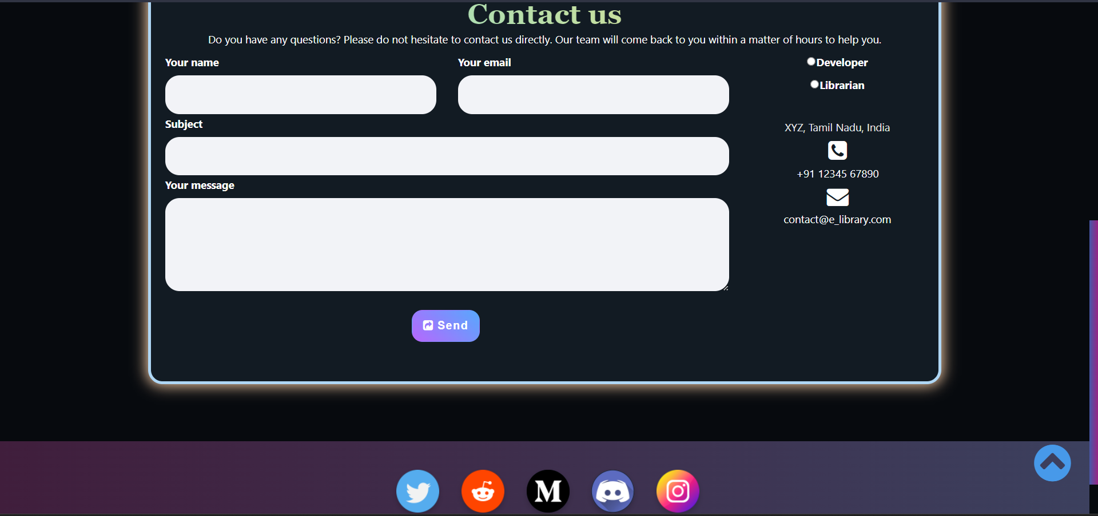

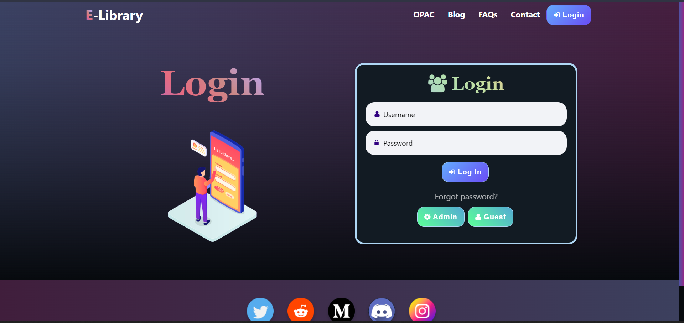

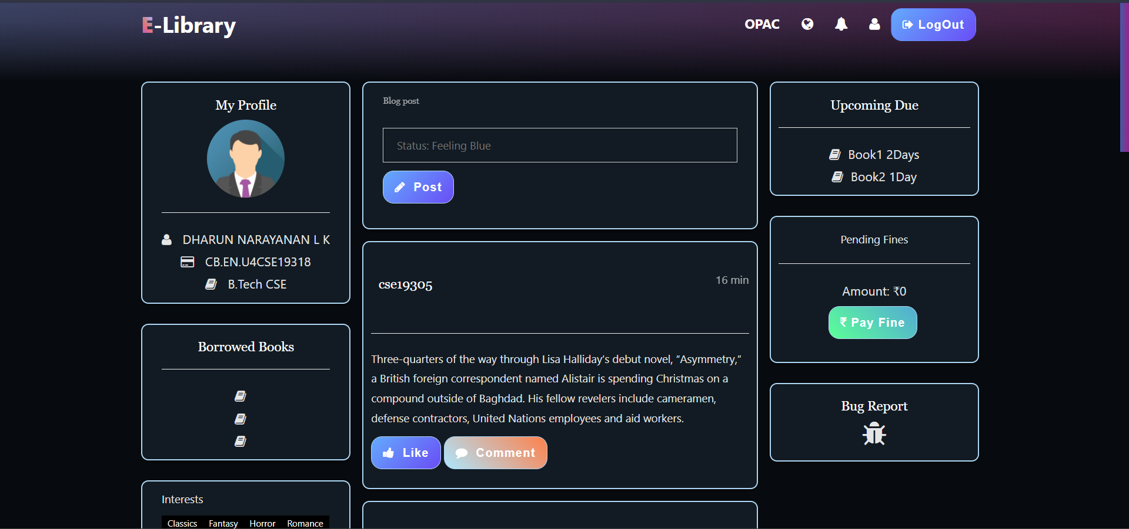

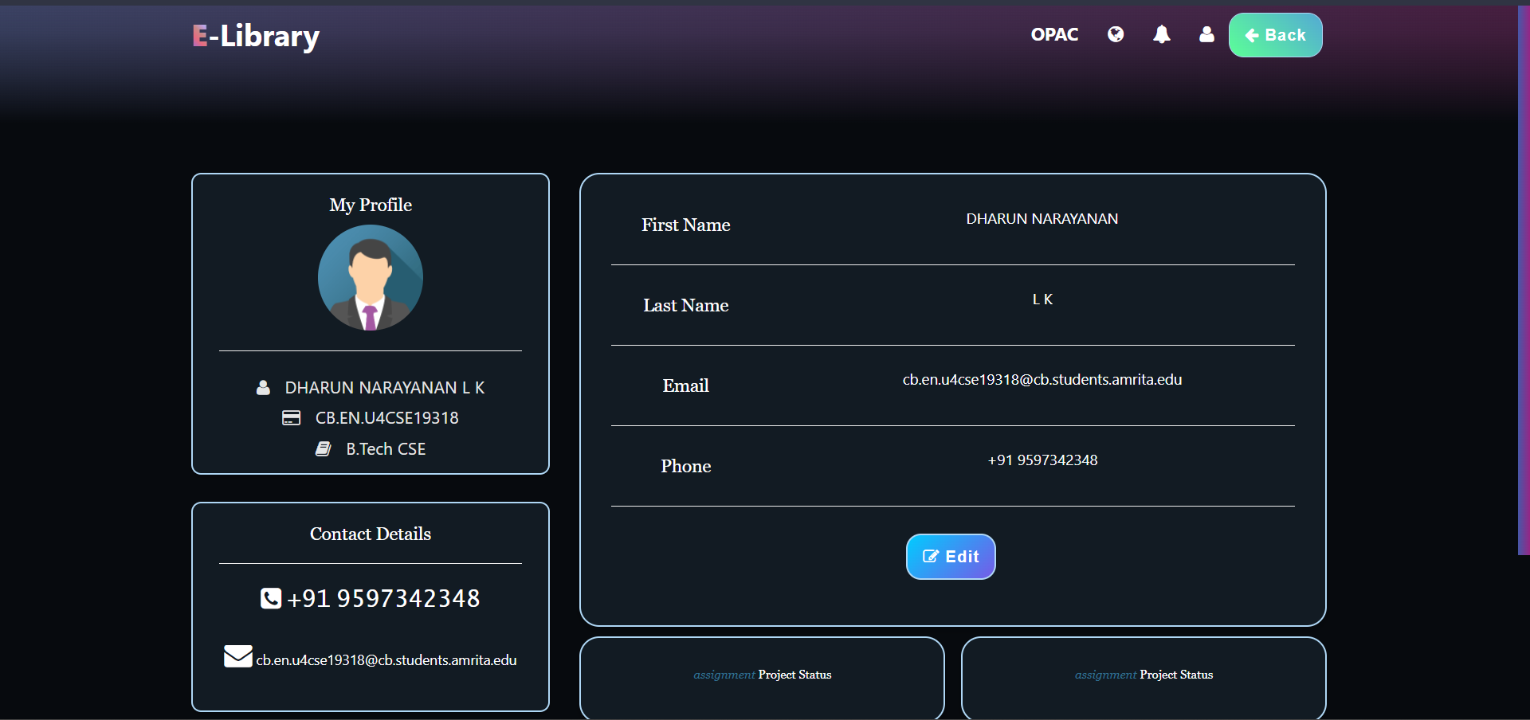

**9] CONCLUSION**

The aim of this project was to develop a website and mobile application that helps the admin, users and guest users to access e-books, books and research papers present in our library. As amrita being one of the biggest institutions, looking into the number of users, their details, the borrow history, fine payments and the many other management tasks that come with it are tedious and hectic so a software that can ease out this job of the user and the admin is always in need and this software will now ease out the job of both admin and users.

**10] FUTURE INNOVATIONS**

* Rating for users which helps in prioritizing them during borrow clashes
* Specifying location of books present in racks of library for easy identification to users
* Suggesting books to users based on their previous searches